

**Off-Course Betting Display System (OCBDS)**

**PPM Project No 91110**

**System Configuration Specification**

# AUTHORISATION

|  |  |  |  |
| --- | --- | --- | --- |
| **Prepared by:** | | | |
| **Project Role** | **Name & Title** | **Signature** | **Date** |
| Development Team Leader | Fredy Wong  IT Project Manager |  |  |
| **Reviewed by:** | | | |
| Project Manager | Parafiniuk, Artur J  IT Programme Manager |  |  |
| **Approved by:** | | | |
| Architecture Team Leader | Ivan Lee  Technical Lead (ITFS) |  |  |
| Technology Standard Group Representative | Edmund Li  Technical Manager (TG&C) |  |  |
| Chief Architect | Mark Carr  Chief Architect |  |  |

# DOCUMENT REVISION HISTORY

|  |  |  |  |  |
| --- | --- | --- | --- | --- |
| Revision No. | Status | Revision Date | Author | Summary of Changes |
| 0.1 | Draft | 31 Jul, 2018 | TVDMS | Draft |
| 0.2 | Draft | 31 Oct, 2018 | TVDMS | DR configuration update |
| 1.0 | Final | 18 May, 2019 | TVDMS | Multicast IP setting |
| 1.1 | Final | 9 Oct, 2019 | TVDMS | Encoder AWS Elemental LA025AE |
| 1.2 | Final | 31 Mar, 2020 | TVDMS | Web Content and TV Wall |

# DOCUMENT LOCATION

|  |  |
| --- | --- |
| Intranet / SharePoint |  |
| EDP.ITD | https://edpapp01.corp.hkjc.com:8243/D2/?docbase=EDPITDS&locateId=0b01b208800a62a0#d2 |

# Table of Contents

AUTHORISATION 1

DOCUMENT REVISION HISTORY 1

DOCUMENT LOCATION 1

Table of Contents 3

PROJECT DESIGN STAGE – SYSTEM CONFIGURATION 5

1.1. Technology Infrastructure 5

Design Concept 5

1.2. TSG Approved System Configurations 6

1.3. Physical Infrastructure Configuration Diagrams 6

1.4. Database Infrastructure Components Configuration Details 10

Database Systems and Versions 10

Data Classification and Back Up Requirement 10

Data Archive 11

Data Recovery 12

1.5. System Infrastructure Components Configuration Details 12

Web Servers 12

System OS Platform 12

Application Servers 13

System OS Platform 13

Monitoring Servers 14

System OS Platform 14

Windows Domain / Active Directory 15

Application and Tools 15

Terminal Service Configuration / Printer Setup 15

1.6. Network Infrastructure Components Configuration Details 16

Types of Network 16

Network Protocol 16

TCP/IP Networking Configuration – CR006 16

TCP/IP Networking Configuration 22

Types of Storage Device 43

Microsoft Cluster Configuration 43

1.7. Hardware Infrastructure Components Configuration Details 45

1.8. System Management Infrastructure Components Configuration Details 53

Integration with EMS 53

Audit Trail 53

1.9. Security Infrastructure Components Configuration Details 53

User Account 53

Anti-virus Software 54

TrendMicro OfficeScan 54

1.10. Video Encoder Configuration 54

Appendix A: Development Test Configuration at Top Vista (Vendor) 56

Appendix B: UAT/SAT Test Configuration 57

Appendix C: CR006 - DR Site Setup 64

Appendix D: CR008/CR013 – Video Quality Enhancement 67

Appendix E: Display External Webpage 68

Appendix F: TV Wall 69

# PROJECT DESIGN STAGE – SYSTEM CONFIGURATION

* 1. Technology Infrastructure

Below is the logical diagram of Symantec WSS solution for OCBDS:

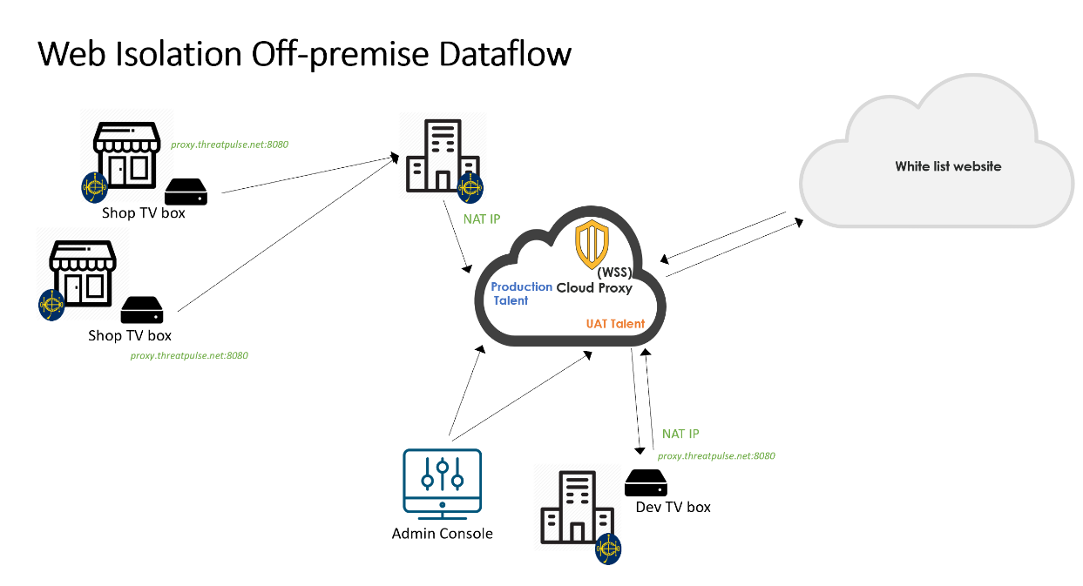

OCBDS Network

Design Concept

Symantec Web Security Service (WSS) delivers web and cloud security from a diversified network of global datacenters. Also, its capabilities allow administrators to define protection policies once and distribute them to all of their gateways. The WSS enforces granular access and security policies that manage web Internet usage by app, user or location. The functionality includes:

* URL Filtering and Categorization that could block web attacks
* Advanced Threat Protection which consists of multi-layered anti-virus and heuristic analysis combines to block malware. Also, it can utilize customizied White-List/Black-List capabilities and file reputation analysis
* Malware Analysis Service leverage advanced analysis (static code, YARA rules, behavioral) as well as inline, real-time file blocking to combat threats
  1. TSG Approved System Configurations

|  |  |  |
| --- | --- | --- |
| Category | Domain | Name |
| Software Development | Service Build | ASP.NET CORE 1.0 or later |
| .NET Framework 4.5 or later |
| Entity Framework 6.1 or later |
| User Interaction Service | IIS v8.5 |
| Software Engineering | HTML 5.0 or later |
| CSS 3.0 or later |
| React JS 15.3.1 |
| JQuery 3.2.1 |
| OS and License | Infrastructure Services | SQL Server |
| Platforms | Windows Server |
| Hardware | Infrastructure Services | HP Server (DL360 (Gen9 E5-2620), DL120 (Gen9 E5 2600), DL20 (Gen9 E3 1270v5)) |
| Cisco Router - ASR1001X, Cisco IOS XE Software Release 3.12.0 |
| Cisco Switch (Catalyst 3850 – Cisco IOS® XE Software Release 16.3,  Catalyst C3650-24TS-S – Cisco IOS® XE Software Release 16.3,  Cisco Catalyst WS-C2960X-24TS-L – Cisco IOS® Software Release 15.2.2E6.) |
|  |  |

* 1. Physical Infrastructure Configuration Diagrams

The following diagram is showing the overall configuration of SCTC Data Centers and 102 OCB locations. It covers the hardware, network connection and sources provided by the Club.

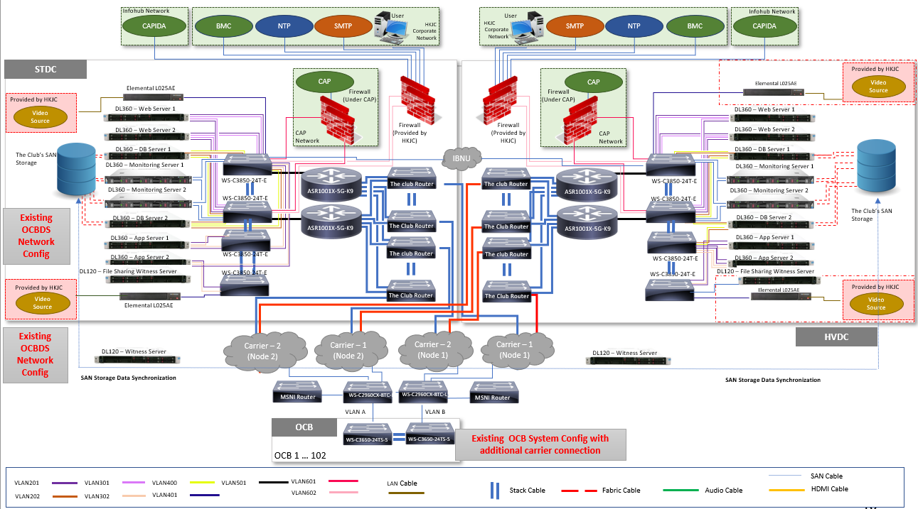

*Remarks: NTP service is available as subscribed to the Club’s corporate domain*

1. **EYECON HQ Server**

Four types of servers, Web Server, Application Server, Database Server, Monitoring Server will be set up with flexibility to extend to multi instances.

* 1. **Web Servers (Host 1 and Host 2 in ST and HV Site – HPE ProLiant DL360)**

Each Web Server is configured with two virtual machines, one is in duty/standby configuration mainly handling administration console, FB admin console, system management and system monitoring, etc.

* 1. **Application Servers (Host 3 and Host 4 in ST and HV Site – HPE ProLiant DL360)**

Application Servers each configured with 1 virtual machines, are configured in duty/standby configuration mainly handling CAP-IDA interface, data massage and publishing massaged data to EYECON Gateway Servers (Local OCB servers)

* 1. **Database Servers (DB Server 1 and DB Server 2 in ST and HV Site – HPE ProLiant DL360)**

Both Database Servers in ST and HV Site will form an SQL Geo-cluster for hosting the EYECON R2 Databases, and the Databases of Customize components:

CAP-IDA Listener Database: Massaged CAP-IDA data for distribution to local OCB Servers which will eventually sent to all relevant players for content display.

Football-Admin Database: Database for football Admin.

Database located in ST SAN will synchronize with that in HV using SRDF as indicated in the diagram below: -

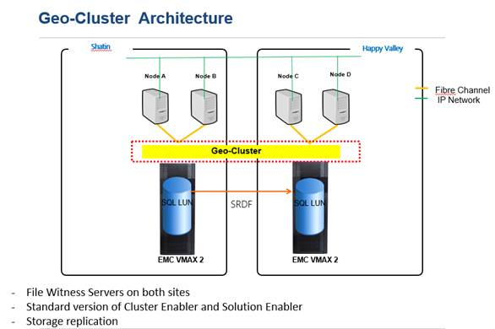

1. **Share Storage for Database Servers (Provided by Club)**

The Club’s SAN Shared StorageShared Storage is connected to Database Servers via Fibre links for caching CAP-IDA and also connected to monitoring servers for BMC log file update and user resources storage. EMC Max 2 is adopted by the Club as geo-cluster infrastructure by hardware vendor Microsoft and EMC.

Geo-cluster DB transaction latency:

* Data disk: Avg = <10ms; avg. size of each transaction ~1KB; max disk transfer/sec = 8823
* Log disk: Avg = <10ms; avg. size of each transaction ~2KB; max disk transfer/sec = 642

1. **Monitoring Servers (HPE ProLiant DL360)**

Both monitoring servers will form a File server cluster for hosting centralize monitoring logs and store system information. These servers will log all events and alarms generated from the OCBDS including all headend servers, network equipment, and local OCB servers and players. Critical alarms will be logged in separate log files in predefined format so that the Club’s BMC system will be able to retrieve the alarms and notify relevant personnel.

1. **Share Storage for Monitoring Server (Provided by Club)**

The Club’s SAN Shared Storage is connected to Monitoring Servers via Fibre links to provide high availability file share to storing collected logs and system information, such as admin rights, templates, e-posters, video contents, etc

1. **Data Centre Core Switches (WS-C3850T-E)**

The data centre core switches are stacked for network resilience and connect to OCBDS duty/standby servers and provide uninterrupted services. They also connect the two sets of video encoders to provide live video streaming to signage players in OCB’s.

1. **Core Routers (ASR-1001X-5G-K9)**

The Core Routers connect separately to the Club’s WAN link

1. **Firewall (Foritgate 101E - provided by the Club)**

Two firewalls shall be provided by the Club for connection of OCBDS to the Club’s corporate and infohub network with duty/standby configuration, further coordination with the Club is required for network setting, server configuration to match the Club’s requirement on firewall connection. It is expected the IP whitelist shall be implemented to ensure only the dedicated Desktop PC can access the OCBDS console.

1. **Video Encoders**

Two sets of AWS Elemental LA025AE video encoders are provided for encoding live video streaming (with 1 video channel and 3 audio channels) and distribute to OCB signage players via RTP multicast.

1. **OCB switches (WS-365024TS-S)**

The OCB switches connect the OCB servers and players to the OCBDS.

1. **OCB Server (HPE ProLiant DL20)**

The OCB servers are under duty/standby configuration. They will cache all the updated template information and massaged CAP-IDA data and eventually distribute to all signage players in the same OCB for content display. All OCB servers will be installed with Eyecon Gateway Server application.

1. **Signage player (iBase SI-102N and iBase SI-613)**
   * 1. SI-102N Signage players is connected to maximum two dedicated display panels, via HDMI output, in OCB’s for display of odds, live broadcast, Racing/FB result, Mark Six result, etc.
     2. SI-613 Signage players is connected to maximum three dedicated video wall panels, via HDMI output, for displaying e-poster, mark six drawn, pre-recorded video content, etc.
     3. SI-614 Signage players is connected to the TV wall screens, via RF and Media Gateway (WellAV CMP201) output, for displaying live football, live racing, e-poster, mark six drawn, pre-recorded video content, etc.

All signage players are installed with EYECON Player application.

The details of subnets should be included in the physical infrastructure configuration diagram.

* 1. Database Infrastructure Components Configuration Details

Database Systems and Versions

| Database Systems | Versions | Patch Number | Number of DB license |
| --- | --- | --- | --- |
| Microsoft SQL Server | 2016 SP1 | KB4040714 (Cumulative Update Package 1) | 2 x Microsoft SQL 2016 Enterprise License (Provided by The Club)  8 x core licenses (4 core licenses per SQL server) |

{Database Systems, versions and patch number as per Configuration Standards Compliance Form. The number of database licensing Purchase Information should be stated}

Data Classification and Back Up Requirement

Production **Configuration** (Remark: This configuration is for GEO cluster)

| Part. A System Information | | | | | | | | | |
| --- | --- | --- | --- | --- | --- | --- | --- | --- | --- |
| System Name  EYECON R2 Databases Servers | | | | Host Names  STOCBDSDB001, STOCBDSDB002, HVOCBDSDB001, HVOCBDSDB002 | | | | | |
| Part. B Data Classification | | | | | | | | | |
| Drive | Data Size (GB) | Usage (OS, DB, Log, Working space…) | | | | | Data Clone Copy | | |
| NO Copy | Local Copy | Remote Copy |
|  |  |  | | | | | {Y/N} | {Y/N} | {Y/N} |
| C: (Local) | 200 GB | OS + Windows patches + SQLApps | | | | |  | Y |  |
| D:  (Local) | 300 GB | Drive for Backup | | | | |  |  |  |
| M: (SAN) | 1 GB | Drive for MSDTC | | | | |  | Y | Y |
| File Share Witness URL | 1GB | Provided by HKJC (File share URL for Quorum) | | | | |  |  |  |
| F: (SAN) | 10 GB | Drive for System DB | | | | |  | Y | Y |
| T: (SAN) | 10 GB | Drive for Temp DB | | | | |  | Y | Y |
| S: (SAN) | 250 GB (Already upgraded to 250GB) | Drive for User DB Backup Dump  CAPIDA.DB + SignalR backupplanDB + Background Task DB + EYECONR2 Standard DB + System + Temp | | | | |  |  | Y |
| J: (SAN) | 20 GB | Drive for 1st User DB Data | | | | |  | Y | Y |
| L: (SAN) | 60 GB (Already upgrade to 60 GB) | Drive for 1st User Transaction Logs | | | | |  | Y | Y |
| Part. C Backup Requirement | | | | | | | | | |
| Backup directory | | | Policy (Daily, Weekly…) | | Type (Full / Incremental) | Retention Period* | | | |
| S:\DBBackup-Daily | | | Daily | | Full | 1 day | | | |

Data Archive

Refer to ITO for current practice.

Data Recovery

Backup Requirement: Daily Full for both OS and databases level.

| Scenario | Action Take | Time Estimate |
| --- | --- | --- |
| DL360 DB Server 1 dead | -       Evict Node 1 from cluster  -       Re-setup OS in Node 1  -       Configure Microsoft Cluster Server to add Node 1  -       Run SQL Server setup to add Node 1 to the failover cluster | 150 minutes |
| DL360 DB Server 2 dead | -       Evict Node 2 from cluster  -       Re-setup OS in Node 2  -       Configure Microsoft Cluster Server to add Node 2  -       Run SQL Server setup to add Node 2 to the failover cluster | 150 minutes |
| Database corrupt | * Open SQL management studio * Restore SQL Database from last night backup | 120 minutes |

* 1. System Infrastructure Components Configuration Details

Web Servers

System OS Platform

| Operating Systems | Versions | Patch Number | Number of OS license |
| --- | --- | --- | --- |
| Microsoft Windows Standard | 2012R2 | 2017-09 Security Monthly Quality Rollup for Windows Server 2012 R2 for x64-based Systems (KB4038792) | 2 x 8 cores pack for windows 2016 Standard Server License |

| System Information | | | | | | | | | |
| --- | --- | --- | --- | --- | --- | --- | --- | --- | --- |
| System Name  Application Servers | | | | Host Names  STOCBDSWS01, STOCBDSWS02, HVOCBDSWS01, HVOCBDSWS02 | | | | | |
| Part. B Data Classification | | | | | | | | | |
| Drive | Data Size (GB) | Usage (OS, Apps, Working space…) | | | | | Data Clone Copy | | |
| NO Copy | Local Copy | Remote Copy |
|  |  |  | | | | | {Y/N} | {Y/N} | {Y/N} |
| C: (Local) | 180 GB | OS + Apps | | | | |  | Y |  |
| D:  (Local) | 110 GB | Drive for Backup | | | | |  |  |  |
| Part. C Backup Requirement | | | | | | | | | |
| Backup directory | | | Policy (Daily, Weekly…) | | Type (Full / Incremental) | Retention Period* | | | |
| D:\Backup | | | Daily | | Full | 1 day | | | |

Application Servers

System OS Platform

| Operating Systems | Versions | Patch Number | Number of OS license |
| --- | --- | --- | --- |
| Microsoft Windows Standard | 2012R2 | 2017-09 Security Monthly Quality Rollup for Windows Server 2012 R2 for x64-based Systems (KB4038792) | 2 x 8 cores pack for windows 2016 Standard Server License |

| System Information | | | | | | | | | |
| --- | --- | --- | --- | --- | --- | --- | --- | --- | --- |
| System Name  Application Servers | | | | Host Names  STOCBDSAS01, STOCBDSAS02, HVOCBDSAS01, HVOCBDSAS02 | | | | | |
| Part. B Data Classification | | | | | | | | | |
| Drive | Data Size (GB) | Usage (OS, Apps, Working space…) | | | | | Data Clone Copy | | |
| NO Copy | Local Copy | Remote Copy |
|  |  |  | | | | | {Y/N} | {Y/N} | {Y/N} |
| C: (Local) | 180 GB | OS + Apps | | | | |  | Y |  |
| D:  (Local) | 110 GB | Drive for Backup | | | | |  |  |  |
| Part. C Backup Requirement | | | | | | | | | |
| Backup directory | | | Policy (Daily, Weekly…) | | Type (Full / Incremental) | Retention Period* | | | |
| D:\Backup | | | Daily | | Full | 1 day | | | |

Monitoring Servers

System OS Platform

|  |  |  |  |
| --- | --- | --- | --- |
| Operating Systems | Versions | Patch Number | Number of OS license |
| Microsoft Windows Standard | 2012R2 | 2017-09 Security Monthly Quality Rollup for Windows Server 2012 R2 for x64-based Systems (KB4038792) | 2 x 8 cores pack for windows 2016 Standard Server License |

Production **Configuration**

| System Information | | | | | | | | | |
| --- | --- | --- | --- | --- | --- | --- | --- | --- | --- |
| System Name  Monitoring Servers | | | | Host Names  STOCBDSMON001, STOCBDSMON002, HVOCBDSMON001, HVOCBDSMON002 | | | | | |
| Part. B Data Classification | | | | | | | | | |
| Drive | Data Size (GB) | Usage (OS, DB, Log, Working space…) | | | | | Data Clone Copy | | |
| NO Copy | Local Copy | Remote Copy |
|  |  |  | | | | | {Y/N} | {Y/N} | {Y/N} |
| C: (Local) | 180 GB | OS + Apps | | | | |  | Y |  |
| D:  (Local) | 300 GB | Drive for Backup | | | | |  | Y |  |
|  |  |  | | | | |  |  |  |
| File Share Witness URL | 1GB | Provided by HKJC (File share URL for Quorum) | | | | |  |  |  |
| K: (SAN) | 300GB | Drive for Systems Information | | | | |  | Y | Y |
| L: (SAN) | 10GB | Drive for Monitoring Logs | | | | |  | Y | Y |
| Part. C Backup Requirement | | | | | | | | | |
| Backup directory | | | Policy (Daily, Weekly…) | | Type (Full / Incremental) | Retention Period* | | | |
| D:\Backup | | | Daily | | Full | 1 day | | | |

* Refer to ITO for current service levels

Windows Domain / Active Directory

All servers will join corp.hkjc.com. In order to match HKJC standard, the servers naming convention shall be provided by HKJC.

Application and Tools

|  |  |  |
| --- | --- | --- |
| Application | Function | Remarks |
| FFmpeg | Convert video format | Open source |
| VLC | Play live video stream | Open source |

Terminal Service Configuration / Printer Setup

N/A

* 1. Network Infrastructure Components Configuration Details

Types of Network

Network Protocol

|  |  |  |
| --- | --- | --- |
| Name(layer) | Names of protocols | Description |
| Hardware(link) | ethernet | Allows messages to be packaged and sent between physical locations. |
| Package management(network) | IP, ICMP | Manages movement of messages and reports errors. It uses message protocols and software to manage this process. (includes routing) |
| Inter layer communication | ARP | Communicates between layers to allow one layer to get information to support another layer. This includes broadcasting |
| Service control(transport) | TCP, UDP | Controls the management of service between computers. Based on values in TCP and UDP messages a server knows what service is being requested. |
| Application and user support | DNS, RPC, LDAP, Kerberos, SMB, DCOM, DFSN, NetLogon, SQL Instance, | DNS provides address to name translation for locations and network cards. RPC allows remote computer to perform functions on other computers. |
| Network Management | RARP, IGMP, SNMP, OSPF | Enhances network management and increases functionality |

Firewall Configuration to be provided by HKJC.

TCP/IP Networking Configuration – CR006

|  |  |  |
| --- | --- | --- |
| Host Name | STOCBDSAS01 | HVOCBDSAS01 |
| DNS domain (Primary DNS suffix) | corp.hkjc.com | corp.hkjc.com |
| Fully Qualified Domain Name (Full Computer Name) | stocbsas01.corp.hkjc.com | hvocbsas01.corp.hkjc.com |
| IP Address | NIC_1: 10.160.2.8  NIC_2: 10.160.5.8 (NLB endpoint)  NLB Virtual: 10.160.5.10 | NIC_1: 10.160.18.8 NIC_2: 10.160.21.8(NLB endpoint)  NLB Virtual: 10.160.21.10 |
| NetMask | 255.255.255.0 | 255.255.255.0 |
| Default Gateway | 10.160.2.254 (Host gateway)  10.160.5.254 (NLB gateway) | 10.160.18.254 (Host gateway)  10.160.21.254 (NLB gateway) |
| DNS Servers Search Order | Corp ST machines  *10.140.1.1*  *10.140.41.1* | Corp HV machines  *To be confirmed* |
| DNS Domain Suffix Search Order | Corp machines  *corp.hkjc.com*  *corpqc.hkjc.com*  *corpdev.hkjc.com* | Corp machines  *To be confirmed* |
| WINS servers | Corp ST machines  10.140.41.4  10.140.1.3 | Corp HV machines  *10.140.1.3*  *10.140.41.4* |
| NTP servers (Time Service) | This computer is member of AD domain | This computer is member of AD domain |

|  |  |  |
| --- | --- | --- |
| Host Name | STOCBDSAS02 | HVOCBDSAS02 |
| DNS domain (Primary DNS suffix) | corp.hkjc.com | corp.hkjc.com |
| Fully Qualified Domain Name (Full Computer Name) | stocbdsas02.corp.hkjc.com | hvocbsas02.corp.hkjc.com |
| IP Address | NIC_1: 10.160.2.9  NIC_2: 10.160.5.9 (NLB endpoint)  NLB Virtual: 10.160.5.10 | NIC_1: 10.160.18.9 NIC_2: 10.160.21.9(NLB endpoint)  NLB Virtual: 10.160.21.10 |
| NetMask | 255.255.255.0 | 255.255.255.0 |
| Default Gateway | 10.160.2.254 (Host gateway)  10.160.5.254 (NLB gateway) | 10.160.18.254 (Host gateway)  10.160.21.254 (NLB gateway) |
| DNS Servers Search Order | Corp ST machines  *10.140.1.1*  *10.140.41.1* | Corp HV machines  *10.140.1.1*  *10.140.41.1* |
| DNS Domain Suffix Search Order | Corp machines  *corp.hkjc.com*  *corpqc.hkjc.com*  *corpdev.hkjc.com* | Corp machines  *corp.hkjc.com*  *corpqc.hkjc.com*  *corpdev.hkjc.com* |
| WINS servers | Corp ST machines  *10.140.41.4*  *10.140.1.3* | Corp HV machines  *10.140.1.3*  *10.140.41.4* |
| NTP servers (Time Service) | This computer is member of AD domain | This computer is member of AD domain |

|  |  |  |
| --- | --- | --- |
| Host Name | STOCBDSWS01 | HVOCBDSWS01 |
| DNS domain (Primary DNS suffix) | corp.hkjc.com | corp.hkjc.com |
| Fully Qualified Domain Name (Full Computer Name) | stocbdsws01.corp.hkjc.com | hvocbsws01.corp.hkjc.com |
| IP Address | NIC_1: 10.160.2.1  NIC_2: 10.160.4.1 (NLB endpoint)  NLB Virtual: 10.160.4.3 | NIC_1: 10.160.18.1  NIC_2: 10.160.20.1 (NLB endpoint)  NLB Virtual: 10.160.20.3 |
| NetMask | 255.255.255.0 | 255.255.255.0 |
| Default Gateway | 10.160.2.254 (Host gateway)  10.160.4.254 (NLB gateway) | 10.160.18.254 (Host gateway)  10.160.20.254 (NLB gateway) |
| DNS Servers Search Order | Corp ST machines (Depends on which Domain to join), below is sample only.  *10.140.1.1*  *10.140.41.1* | Corp HV machines  *10.140.1.1*  *10.140.41.1* |
| DNS Domain Suffix Search Order | Corp machines  *corp.hkjc.com*  *corpqc.hkjc.com*  *corpdev.hkjc.com* | Corp machines  *corp.hkjc.com*  *corpqc.hkjc.com*  *corpdev.hkjc.com* |
| WINS servers | Corp ST machines  10.140.41.4  10.140.1.3 | Corp HV machines  *10.140.1.3*  *10.140.41.4* |
| NTP servers (Time Service) | This computer is member of AD domain | This computer is member of AD domain |

|  |  |  |
| --- | --- | --- |
| Host Name | STOCBDSWS02 | HVOCBDSWS02 |
| DNS domain (Primary DNS suffix) | corp.hkjc.com | corp.hkjc.com |
| Fully Qualified Domain Name (Full Computer Name) | stocbdsws02.corp.hkjc.com | hvocbsws02.corp.hkjc.com |
| IP Address | NIC_1: 10.160.2.2  NIC_2: 10.160.4.2 (NLB endpoint)  NLB Virtual: 10.160.4.3 | NIC_1: 10.160.18.2  NIC_2: 10.160.20.2 (NLB endpoint)  NLB Virtual: 10.160.20.3 |
| NetMask | 255.255.255.0 | 255.255.255.0 |
| Default Gateway | 10.160.2.254 (Host gateway)  10.160.4.254 (NLB gateway) | 10.160.18.254 (Host gateway)  10.160.20.254 (NLB gateway) |
| DNS Servers Search Order | Corp ST machines (Depends on which Domain to join), below is sample only.  *10.140.1.1*  *10.140.41.1* | Corp HV machines  *To be confirmed* |
| DNS Domain Suffix Search Order | Corp machines  *corp.hkjc.com*  *corpqc.hkjc.com*  *corpdev.hkjc.com* | Corp machines  *To be confirmed* |
| WINS servers | Corp ST machines  10.140.41.4  10.140.1.3 | Corp HV machines  *10.140.1.3*  *10.140.41.4* |
| NTP servers (Time Service) | This computer is member of AD domain | This computer is member of AD domain |

**Production Configuration**

|  |  |  |
| --- | --- | --- |
| Host Name | STOCBDSMON001 | HVOCBDSMON001 |
| DNS domain (Primary DNS suffix) | corp.hkjc.com | corp.hkjc.com |
| Fully Qualified Domain Name (Full Computer Name) | stocbdsmon001.corp.hkjc.com | hvocbdsmon001.corp.hkjc.com |
| IP Address | NIC_1: 10.160.2.14  Cluster Group Virtual Name: GCOCBDSMONCG  Cluster Group Virtual IP: 10.160.2.16  Cluster Group Virtual Server: GCOCBDSMONFS01  Cluster Group Virtual IP: 10.160.2.7 | NIC_1: 10.160.18.14  Cluster Group Virtual Name: GCOCBDSMONCG  Cluster Group Virtual IP: 10.160.18.16  Cluster Group Virtual Server: GCOCBDSMONFS01  Cluster Group Virtual IP: 10.160.18.7 |
| NetMask | 255.255.255.0 | 255.255.255.0 |
| Default Gateway | 10.160.2.254 (Host gateway) | 10.160.18.254 (Host gateway) |
| DNS Servers Search Order | Corp ST machines (Depends on which Domain to join), below is sample only.  *10.140.1.1*  *10.140.41.1* | Corp HV machines  *To be confirmed* |
| DNS Domain Suffix Search Order | Corp machines  *corp.hkjc.com*  *corpqc.hkjc.com*  *corpdev.hkjc.com* | Corp machines  *To be confirmed* |
| WINS servers | Corp ST machines  10.140.41.4  10.140.1.3 | Corp HV machines  *10.140.1.3*  *10.140.41.4* |
| NTP servers (Time Service) | This computer is member of AD domain | This computer is member of AD domain |

**Production Configuration**

|  |  |  |
| --- | --- | --- |
| Host Name | STOCBDSMON002 | HVOCBDSMON002 |
| DNS domain (Primary DNS suffix) | corp.hkjc.com | corp.hkjc.com |
| Fully Qualified Domain Name (Full Computer Name) | stocbdsmon002.corp.hkjc.com | hvocbdsmon002.corp.hkjc.com |
| IP Address | NIC_1: 10.160.2.15  Cluster Group Virtual Name: GCOCBSMONCG  Cluster Group Virtual IP: 10.160.2.16  Cluster Group Virtual Server: GCOCBDSMONFS01  Cluster Group Virtual IP: 10.160.2.17 | NIC_1: 10.160.18.15  Cluster Group Virtual Name: GCOCBSMONCG  Cluster Group Virtual IP: 10.160.18.16  Cluster Group Virtual Server: GCOCBDSMONFS01  Cluster Group Virtual IP: 10.160.18.17 |
| NetMask | 255.255.255.0 | 255.255.255.0 |
| Default Gateway | 10.160.2.254 (Host gateway) | 10.160.18.254 (Host gateway) |
| DNS Servers Search Order | Corp ST machines (Depends on which Domain to join), below is sample only.  *10.140.1.1*  *10.140.41.1* | Corp HV machines  *To be confirmed* |
| DNS Domain Suffix Search Order | Corp machines  *corp.hkjc.com*  *corpqc.hkjc.com*  *corpdev.hkjc.com* | Corp machines  *To be confirmed* |
| WINS servers | Corp ST machines  10.140.41.4  10.140.1.3 | Corp HV machines  *To be confirmed*  10.140.1.3  10.140.41.4 |
| NTP servers (Time Service) | This computer is member of AD domain | This computer is member of AD domain |

**Production Configuration** (Remark: This configuration is for GEO cluster)

|  |  |  |
| --- | --- | --- |
| Host Name | STOCBDSDB001 | HVOCBDSDB001 |
| DNS domain (Primary DNS suffix) | corp.hkjc.com | corp.hkjc.com |
| Fully Qualified Domain Name (Full Computer Name) | stocbddsb001.corp.hkjc.com | hvocbddsb001.corp.hkjc.com |
| IP Address | NIC_1: 10.160.3.11  Cluster Group Virtual Name: GCOCBDSDBCG  Cluster Group Virtual IP: 10.160.3.13  Cluster Group Virtual Server: GCOCBDSDBDTC  Cluster Group Virtual IP: 10.160.3.14  Cluster Group Virtual Server: GCOCBDSDB03  Cluster Group Virtual IP: 10.160.3.15 | NIC_1: 10.160.19.11  Cluster Group Virtual Name: GCOCBDSDBCG  Cluster Group Virtual IP: 10.160.19.13  Cluster Group Virtual Server: GCOCBDSDBDTC  Cluster Group Virtual IP: 10.160.19.14  Cluster Group Virtual Server: GCOCBDSDB03  Cluster Group Virtual IP: 10.160.19.15 |
| NetMask | 255.255.255.0 | 255.255.255.0 |
| Default Gateway | 10.160.3.254 (Host gateway) | 10.160.19.254 (Host gateway) |
| DNS Servers Search Order | Corp ST machines (Depends on which Domain to join), below is sample only.  *10.140.1.1*  *10.140.41.1* | Corp HV machines  *To be confirmed* |
| DNS Domain Suffix Search Order | Corp machines  *corp.hkjc.com*  *corpqc.hkjc.com*  *corpdev.hkjc.com* | Corp machines  *To be confirmed* |
| WINS servers | Corp ST machines  10.140.41.4  10.140.1.3 | Corp HV machines  *10.140.1.3*  *10.140.41.4* |
| NTP servers (Time Service) | This computer is member of AD domain | This computer is member of AD domain |

**Production Configuration** (Remark: This configuration is for GEO cluster)

|  |  |  |
| --- | --- | --- |
| Host Name | STOCBDSDB002 | HVOCBDSDB002 |
| DNS domain (Primary DNS suffix) | corp.hkjc.com | corp.hkjc.com |
| Fully Qualified Domain Name (Full Computer Name) | stocbdsdb002.corp.hkjc.com | hvocbddsb002.corp.hkjc.com |
| IP Address | NIC_1: 10.160.3.12  Cluster Group Virtual Name: GCOCBDSDBCG  Cluster Group Virtual IP: 10.160.3.13  Cluster Group Virtual Server: GCOCBDSDBDTC  Cluster Group Virtual IP: 10.160.3.14  Cluster Group Virtual Server: GCOCBDSDB03  Cluster Group Virtual IP: 10.160.3.15 | NIC_1: 10.160.19.12  Cluster Group Virtual Name: GCOCBDSDBCG  Cluster Group Virtual IP: 10.160.19.13  Cluster Group Virtual Server: GCOCBDSDBDTC  Cluster Group Virtual IP: 10.160.19.14  Cluster Group Virtual Server: GCOCBDSDB03  Cluster Group Virtual IP: 10.160.19.15 |
| NetMask | 255.255.255.0 | 255.255.255.0 |
| Default Gateway | 10.160.3.254 (Host gateway) | 10.160.19.254 |
| DNS Servers Search Order | Corp ST machines (Depends on which Domain to join), below is sample only.  *10.140.1.1*  *10.140.41.1* | Corp HV machines  *To be confirmed* |
| DNS Domain Suffix Search Order | Corp machines  *corp.hkjc.com*  *corpqc.hkjc.com*  *corpdev.hkjc.com* | Corp machines  *To be confirmed* |
| WINS servers | Corp ST machines  10.140.41.4  10.140.1.3 | Corp HV machines  *10.140.1.3*  *10.140.41.4* |
| NTP servers (Time Service) | This computer is member of AD domain | This computer is member of AD domain |

TCP/IP Networking Configuration

SAT1 Configuration (Remark: This configuration is for SAT1 enhanced resilience)

|  |  |
| --- | --- |
| Host Name | QCOCBDSAS001 |
| DNS domain (Primary DNS suffix) | corpqc.hkjc.com |
| Fully Qualified Domain Name (Full Computer Name) | qcocbsas001.corpqc.hkjc.com |
| IP Address | NIC_1: 10.72.160.72  NIC_2: 10.72.160.168(NLB endpoint)  NLB Virtual: 10.72.160.170 |
| NetMask | 255.255.255.224 |
| Default Gateway | 10.72.160.94 (Host gateway)  10.72.160.190 (NLB gateway) |
| DNS Servers Search Order | Corp ST machines  *10.140.1.1*  *10.140.41.1* |
| DNS Domain Suffix Search Order | Corp machines  *corpqc.hkjc.com*  *corpdev.hkjc.com* |
| WINS servers | Corp ST machines  10.140.41.4  10.140.1.3 |
| NTP servers (Time Service) | This computer is member of AD domain |
|  |  |
| Host Name | QCOCBDSAS002 |
| DNS domain (Primary DNS suffix) | corpqc.hkjc.com |
| Fully Qualified Domain Name (Full Computer Name) | qcocbdsas002.corpqc.hkjc.com |
| IP Address | NIC_1: 10.72.160.73  NIC_2: 10.72.160.169 (NLB endpoint)  NLB Virtual: 10.72.160.170 |
| NetMask | 255.255.255.224 |
| Default Gateway | 10.72.160.94 (Host gateway)  10.72.160.190 (NLB gateway) |
| DNS Servers Search Order | Corp ST machines  *10.140.1.1*  *10.140.41.1* |
| DNS Domain Suffix Search Order | Corp machines  *corpqc.hkjc.com*  *corpdev.hkjc.com* |
| WINS servers | Corp ST machines  *10.140.41.4*  *10.140.1.3* |
| NTP servers (Time Service) | This computer is member of AD domain |
|  |  |

|  |  |
| --- | --- |
| Host Name | QCOCBDSWS001 |
| DNS domain (Primary DNS suffix) | corpqc.hkjc.com |
| Fully Qualified Domain Name (Full Computer Name) | qcocbdsws001.corpqc.hkjc.com |
| IP Address | NIC_1: 10.72.160.65  NIC_2: 10.72.160.129 (NLB endpoint)  NLB Virtual: 10.72.160.131 |
| NetMask | 255.255.255.224 |
| Default Gateway | 10.72.160.94 (Host gateway)  10.72.160.158 (NLB gateway) |
| DNS Servers Search Order | Corp ST machines (Depends on which Domain to join), below is sample only.  *10.140.1.1*  *10.140.41.1* |
| DNS Domain Suffix Search Order | Corp machines  *corpqc.hkjc.com*  *corpdev.hkjc.com* |
| WINS servers | Corp ST machines  10.140.41.4  10.140.1.3 |
| NTP servers (Time Service) | This computer is member of AD domain |

|  |  |
| --- | --- |
| Host Name | QCOCBDSWS002 |
| DNS domain (Primary DNS suffix) | corp.hkjcqc.com |
| Fully Qualified Domain Name (Full Computer Name) | qcocbdsws002.corpqc.hkjc.com |
| IP Address | NIC_1: 10.72.160.66  NIC_2: 10.72.160.130 (NLB endpoint)  NLB Virtual: 10.72.160.131 |
| NetMask | 255.255.255.224 |
| Default Gateway | 10.72.160.94 (Host gateway)  10.72.160.158 (NLB gateway) |
| DNS Servers Search Order | Corp ST machines (Depends on which Domain to join), below is sample only.  *10.140.1.1*  *10.140.41.1* |
| DNS Domain Suffix Search Order | Corp machines  *corpqc.hkjc.com*  *corpdev.hkjc.com* |
| WINS servers | Corp ST machines  10.140.41.4  10.140.1.3 |
| NTP servers (Time Service) | This computer is member of AD domain |

|  |  |
| --- | --- |
| Host Name | QCOCBDSMS001 |
| DNS domain (Primary DNS suffix) | corpqc.hkjc.com |
| Fully Qualified Domain Name (Full Computer Name) | qcocbdsms001.corpqc.hkjc.com |
| IP Address | NIC_1: 10.72.160.68  Cluster Group Virtual Name: QCOCBDSMS003  Cluster Group Virtual IP: 10.72.160.70  Cluster Group Virtual Server: QCOCBDSMS004  Cluster Group Virtual IP: 10.72.160.71 |
| NetMask | 255.255.255.224 |
| Default Gateway | 10.72.160.94 (Host gateway) |
| DNS Servers Search Order | Corp ST machines (Depends on which Domain to join), below is sample only.  *10.140.1.1*  *10.140.41.1* |
| DNS Domain Suffix Search Order | Corp machines  *corpqc.hkjc.com*  *corpdev.hkjc.com* |
| WINS servers | Corp ST machines  10.140.41.4  10.140.1.3 |
| NTP servers (Time Service) | This computer is member of AD domain |

|  |  |
| --- | --- |
| Host Name | QCOCBDSMS002 |
| DNS domain (Primary DNS suffix) | corpqc.hkjc.com |
| Fully Qualified Domain Name (Full Computer Name) | qcocbdsms002.corpqc.hkjc.com |
| IP Address | NIC_1: 10.72.160.69  Cluster Group Virtual Name: QCOCBDSMS003  Cluster Group Virtual IP: 10.72.160.70  Cluster Group Virtual Server: QCOCBDSMS004  Cluster Group Virtual IP: 10.72.160.71 |
| NetMask | 255.255.255.248 |
| Default Gateway | 10.72.160.94 (Host gateway) |
| DNS Servers Search Order | Corp ST machines (Depends on which Domain to join), below is sample only.  *10.140.1.1*  *10.140.41.1* |
| DNS Domain Suffix Search Order | Corp machines  *corpqc.hkjc.com*  *corpdev.hkjc.com* |
| WINS servers | Corp ST machines  10.140.41.4  10.140.1.3 |
| NTP servers (Time Service) | This computer is member of AD domain |

|  |  |
| --- | --- |
| Host Name | QCOCBDSDB001 |
| DNS domain (Primary DNS suffix) | corp.hkjcqc.com |
| Fully Qualified Domain Name (Full Computer Name) | qcocbdsb001.corpqc.hkjc.com |
| IP Address | NIC_1: 10.72.160.97  Cluster Group Virtual Name: QCOCBDSDB003  Cluster Group Virtual IP: 10.72.160.99  Cluster Group Virtual Server: QCOCBDSDB004  Cluster Group Virtual IP: 10.72.160.100  Cluster Group Virtual Server: QCOCBDSDB005  Cluster Group Virtual IP: 10.72.160.101 |
| NetMask | 255.255.255.224 |
| Default Gateway | 10.72.160.126 (Host gateway) |
| DNS Servers Search Order | Corp ST machines (Depends on which Domain to join), below is sample only.  *10.140.1.1*  *10.140.41.1* |
| DNS Domain Suffix Search Order | Corp machines  *corpqc.hkjc.com*  *corpdev.hkjc.com* |
| WINS servers | Corp ST machines  10.140.41.4  10.140.1.3 |
| NTP servers (Time Service) | This computer is member of AD domain |

|  |  |
| --- | --- |
| Host Name | QCOCBDSDB002 |
| DNS domain (Primary DNS suffix) | corp.hkjcqc.com |
| Fully Qualified Domain Name (Full Computer Name) | qcocbdsdb002.corpqc.hkjc.com |
| IP Address | NIC_1: 10.72.160.98  Cluster Group Virtual Name: QCOCBDSDB003  Cluster Group Virtual IP: 10.72.160.99  Cluster Group Virtual Server: QCOCBDSDB004  Cluster Group Virtual IP: 10.72.160.100  Cluster Group Virtual Server: QCOCBDSDB005  Cluster Group Virtual IP: 10.72.160.101 |
| NetMask | 255.255.255.224 |
| Default Gateway | 10.72.160.126 (Host gateway) |
| DNS Servers Search Order | Corp ST machines (Depends on which Domain to join), below is sample only.  *10.140.1.1*  *10.140.41.1* |
| DNS Domain Suffix Search Order | Corp machines  *corpqc.hkjc.com*  *corpdev.hkjc.com* |
| WINS servers | Corp ST machines  10.140.41.4  10.140.1.3 |
| NTP servers (Time Service) | This computer is member of AD domain |

**Network switch Configuration**

C3850 in PRD Site

| **Alias** | | **Description** | | **IP/Mask (vLAN ID)** | | **Subnet Mask** | | **Default Gateway** | | **VLAN ID** | | **Remark** |
| --- | --- | --- | --- | --- | --- | --- | --- | --- | --- | --- | --- | --- |
| **HKJC Project Production Server (VLAN)** | | | | | | | | | | | | |
| A | | **Mgt** | | 10.160.1.0 | | 255.255.255.0 | | 10.160.1.254 | | VLAN111 | |  |
| B | | **Frontend (Web & App)** | | 10.160.2.0 | | 255.255.255.0 | | 10.160.2.254 | | VLAN201 | |  |
| C | | **Backend (Database)** | | 10.160.3.0 | | 255.255.255.0 | | 10.160.3.254 | | VLAN202 | |  |
| D | | **NLB_01 (Frontend Web)** | | 10.160.4.0 | | 255.255.255.0 | | 10.160.4.254 | | VLAN301 | |  |
| E | | **NLB_02 (CAPIDA)** | | 10.160.5.0 | | 255.255.255.0 | | 10.160.5.254 | | VLAN302 | |  |
| F | | **Heartbeat (Database)** | | 192.168 .246 .57 192.168 .246 .58 | | 255.255.255.252 | |  | |  | |  |
| G | | **File Share Witness** | | Provided& Maintained by HKJC | | Provided& Maintained by HKJC | | Provided& Maintained by HKJC | | Provided& Maintained by HKJC | |  |
| H | | **Video Source Network** | | 10.160.6.0 | | 255.255.255.0 | | 10.160.6.254 | | VLAN401 | |  |
| I | | **To ASR01 Router Network (Transit Purpose)** | | 10.160.7.1 | | 255.255.255.248 | |  | | VLAN501 | |  |
| J | | **To ASR02 Router Network (Transit Purpose)** | | 10.160.7.9 | | 255.255.255.248 | |  | | VLAN502 | |  |
| K | | **Firewall (Club Network/CAP-IDE)** | | 10.160.8.0 | | 255.255.255.0 | | 10.160.8.254 | | VLAN601 | |  |
| L | | **Firewall (CAP)** | | 10.160.9.0 | | 255.255.255.0 | | 10.160.9.254 | | VLAN602 | |  |
| M | | **Heartbeat (Monitoring)** | | 192.168 .246 .61 192.168 .246 .62 | | 255.255.255.252 | |  | |  | |  |
| N | | **For Connect to SCTC C3 (Transit Purpose ASR01)** | | 10.160.14.1 | | 255.255.255.248 | |  | | VLAN801 | |  |
| O | | **For Connect to SCTC C3 (Transit Purpose ASR02)** | | 10.160.14.9 | | 255.255.255.248 | |  | | VLAN802 | |  |
| P | | **For SCTC C3 (OCBDS)** | | 10.160.12.0 | | 255.255.255.0 | |  | | VLAN100 | |  |
| Q | | **Loopback Interface** | | 10.160.13.254 | |  | |  | |  | |  |
|  | |  | |  | |  | |  | |  | |  |
|  | | C3850 in DR Site | |  | |  | |  | |  | |  | |
| **Alias** | | **Description** | | **IP/Mask (vLAN ID)** | | **Subnet Mask** | | **Default Gateway** | | **VLAN ID** | | **Remark** |
| **HKJC Project Production Server (VLAN)** | | | | | | | | | | | | |
| A | | **Mgt** | | 10.160.17.0 | | 255.255.255.0 | | 10.160.17.254 | | VLAN112 | |  |
| B | | **Frontend (Web & App)** | | 10.160.18.0 | | 255.255.255.0 | | 10.160.18.254 | | VLAN203 | |  |
| C | | **Backend (Database)** | | 10.160.19.0 | | 255.255.255.0 | | 10.160.19.254 | | VLAN204 | |  |
| D | | **NLB_01 (Frontend Web)** | | 10.160.20.0 | | 255.255.255.0 | | 10.160.20.254 | | VLAN303 | |  |
| E | | **NLB_02 (CAPIDA)** | | 10.160.21.0 | | 255.255.255.0 | | 10.160.21.254 | | VLAN304 | |  |
| F | | **Heartbeat (Database)** | | 192.168 .246 .65 192.168 .246 .66 | | 255.255.255.252 | |  | |  | |  |
| G | | **File Share Witness** | | Provided& Maintained by HKJC | | Provided& Maintained by HKJC | | Provided& Maintained by HKJC | | Provided& Maintained by HKJC | |  |
| H | | **Video Source Network** | | 10.160.22.0 | | 255.255.255.0 | | 10.160.22.254 | | VLAN402 | |  |
| I | | **To ASR01 Router Network (Transit Purpose)** | | 10.160.23.1 | | 255.255.255.248 | |  | | VLAN503 | |  |
| J | | **To ASR02 Router Network (Transit Purpose)** | | 10.160.23.9 | | 255.255.255.248 | |  | | VLAN504 | |  |
| K | | **Firewall (Club Network/CAP-IDE)** | | 10.160.24.0 | | 255.255.255.0 | | 10.160.24.254 | | VLAN603 | |  |
| L | | **Firewall (CAP)** | | 10.160.25.0 | | 255.255.255.0 | | 10.160.25.254 | | VLAN604 | |  |
| M | | **Heartbeat (Monitoring)** | | 192.168 .246 .69 192.168 .246 .70 | | 255.255.255.252 | |  | |  | |  |
| N | | **For Connect to SCTC C3 (Transit Purpose ASR01)** | | 10.160.26.1 | | 255.255.255.248 | |  | | VLAN803 | |  |
| O | | **For Connect to SCTC C3 (Transit Purpose ASR02)** | | 10.160.26.9 | | 255.255.255.248 | |  | | VLAN804 | |  |
| P | | **For SCTC C3 (OCBDS)** | | 10.160.12.0 | | 255.255.255.0 | |  | | VLAN100 | |  |
| Q | | **Loopback Interface** | | 10.160.27.254 | |  | |  | |  | |  |
|  | |  | |  | |  | |  | |  | |  |
|  | |  | |  | |  | |  | |  | |  |
|  | |  | |  | |  | |  | |  | |  |
| **Alias** | | **Description** | | **IP/Mask (Multicast)** | | **Subnet Mask** | |  | |  | |  |
| **HKJC SAT1 and Production Server (Multicast)** | | | | | | | |  | |  | |  |
| A | | **Multicast Group1** | | 239.194.14.1 | | 255.255.255.0 | |  | |  | |  |
| B | | **Multicast Group2** | | 239.194.14.2 | | 255.255.255.0 | |  | |  | |  |
| C | | **Multicast Group3** | | 239.194.14.33 | | 255.255.255.0 | |  | |  | |  |
| D | | **Multicast Group4** | | 239.194.14.34 | | 255.255.255.0 | |  | |  | |  |
|  | |  | |  | |  | |  | |  | |  |

ASR in PRD Site

| **Alias** | **Description** | **IP/Mask (vLAN ID)** | **Subnet Mask** | **Default Gateway** | **VLAN ID** | **Remarks** |
| --- | --- | --- | --- | --- | --- | --- |
| J.1 | **ASR Router1 Network (MSNI/Switch/STD1SW) gi 0/0/2.1 gi 0/0/2.2 gi 0/0/2.3** | 10.160.62.232 10.160.94.242 10.160.126.242 | 255.255.255.0 |  | VLAN322 VLAN324 VLAN728 | Connect to STD1SW G1/0/5 |
| J.2 | **ASR Router1 Network (MSNI/Switch/STE1SW) gi 0/0/3.1 gi 0/0/3.2 gi 0/0/3.3** | 10.160.158.242 10.160.190.242 10.160.222.242 | 255.255.255.0 |  | VLAN722 VLAN724 VLAN726 | Connect to STE1SW G1/0/5 |
| K.1 | **ASR Router2 Network (MSNI/Switch/STD2SW) gi 0/0/2.1 gi 0/0/2.2 gi 0/0/2.3** | 10.160.61.231 10.160.93.231 10.160.125.231 | 255.255.255.0 |  | VLAN321 VLAN323 VLAN727 | Connect to STD2SW G1/0/5 |
| K.2 | **ASR Router2 Network (MSNI/Switch/STE2SW) gi 0/0/3.1 gi 0/0/3.2 gi 0/0/3.3** | 10.160.157.231 10.160.189.231 10.160.221.231 | 255.255.255.0 |  | VLAN721 VLAN723 VLAN725 | Connect to STE2SW G1/0/5 |
| L | **ASR Router1 Network (Connect to C3 3650)** | 10.160.14.1 | 255.255.255.248 |  | VLAN801 | Connect to C3 3650 G1/1/1 |
| M | **ASR Router1 Network (Connect to C3 3650)** | 10.160.14.9 | 255.255.255.248 |  | VLAN802 | Connect to C3 3650 G2/1/1 |

ASR in DR Site

| **Alias** | **Description** | **IP/Mask (vLAN ID)** | **Subnet Mask** | **Default Gateway** | **VLAN ID** | **Remarks** |
| --- | --- | --- | --- | --- | --- | --- |
| J.1 | **ASR Router1 Network (MSNI/Switch/ HVD1SW) gi 0/0/2.1 gi 0/0/2.2 gi 0/0/2.3** | 10.160.62.231 10.160.94.231 10.160.126.231 | 255.255.255.0 |  | VLAN322 VLAN324 VLAN728 | Connect to HVD1SW G1/0/5  (To be confirmed) |
| J.2 | **ASR Router1 Network (MSNI/Switch/HVE1SW) gi 0/0/3.1 gi 0/0/3.2 gi 0/0/3.3** | 10.160.158.231 10.160.190.231 10.160.222.231 | 255.255.255.0 |  | VLAN722 VLAN724 VLAN726 | Connect to HVE1SW G1/0/5  (To be confirmed) |
| K.1 | **ASR Router2 Network (MSNI/Switch/HVD2SW) gi 0/0/2.1 gi 0/0/2.2 gi 0/0/2.3** | 10.160.61.242 10.160.93.242 10.160.125.242 | 255.255.255.0 |  | VLAN321 VLAN323 VLAN727 | Connect to HVD2SW G1/0/5  (To be confirmed) |
| K.2 | **ASR Router2 Network (MSNI/Switch/HVE2SW) gi 0/0/3.1 gi 0/0/3.2 gi 0/0/3.3** | 10.160.157.242 10.160.189.242 10.160.221.242 | 255.255.255.0 |  | VLAN721 VLAN723 VLAN725 | Connect to HVE2SW G1/0/5  (To be confirmed) |
| L | **ASR Router1 Network (Connect to C3 3650)** | 10.160.26.1 | 255.255.255.248 |  | VLAN803 | Connect to C3 3650 G1/1/1 |
| M | **ASR Router1 Network (Connect to C3 3650)** | 10.160.26.9 | 255.255.255.248 |  | VLAN804 | Connect to C3 3650 G2/1/1 |

OCBDS C3650

|  |  |  |  |  |  |
| --- | --- | --- | --- | --- | --- |
| **Alias** | **Description** | **IP/Mask (vLAN ID)** | **Subnet Mask** | **Default Gateway** | **VLAN ID** |
| **HKJC Project OCBS (VLAN)** | | | | | |
| A | **VLAN A**  **connect to ASR01** | 10.160.61.x 10.160.93.x 10.160.125.x 10.160.157.x 10.160.189.x 10.160.221.x | 255.255.255.0 | 10.160.61.231 10.160.93.231 10.160.125.231 10.160.157.231 10.160.189.231 10.160.221.231 | VLAN A |
| B | **VLAN B**  **connect to ASR02** | 10.160.62.x 10.160.94.x 10.160.126.x 10.160.158.x 10.160.190.x 10.160.222.x | 255.255.255.0 | 10.160.62.232 10.160.94.242 10.160.126.242 10.160.158.242 10.160.190.242 10.160.222.242 | VLAN B |
| C | **VLAN100**  **for GW Server**  **& player** | 10.160.33.0 to 10.160.56.0 10.160.65.0 to 10.160.88.0 10.160.99.0 to 10.160.120.0 10.160.129.0 to 10.160.159.0 10.160.161.0 to 10.160.184.0 10.160.193.0 to 10.160.216.0 | 255.255.255.0 | 10.160.33.254 to 10.160.56.254 10.160.65.254 to 10.160.88.254 10.160.99.254 to 10.160.120.254 10.160.129.254 to 10.160.159.254 10.160.161.254 to 10.160.184.254 10.160.193.254 to 10.160.216.254 | VLAN 100 |

**Network switch Configuration**

C3850 in STDC SAT1

| **Alias** | **Description** | **IP/Mask (vLAN ID)** | **Subnet Mask** | **Default Gateway** | **VLAN ID** | **Remark** |
| --- | --- | --- | --- | --- | --- | --- |
| **HKJC Project Production Server (VLAN)** | | | | | | |
| A | **Mgt** | 10.72.160.32 | 255.255.255.224 | 10.72.160.62 | VLAN111 |  |
| B | **Frontend (Web & App)** | 10.72.160.64 | 255.255.255.224 | 10.72.160.94 | VLAN201 |  |
| C | **Backend (Database)** | 10.72.160.96 | 255.255.255.224 | 10.72.160.126 | VLAN202 |  |
| D | **NLB_01 (Frontend Web)** | 10.72.160.128 | 255.255.255.224 | 10.72.160.158 | VLAN301 |  |
| E | **NLB_02 (CAPIDA)** | 10.72.160.160 | 255.255.255.224 | 10.72.160.190 | VLAN302 |  |
| F | **Video Source Network** | 10.72.160.192 | 255.255.255.224 | 10.72.160.190 | VLAN401 |  |
| G | **To ASR01 Router Network (Transit Purpose)** | 10.72.160.225 | 255.255.255.248 | N/A | VLAN501 |  |
| H | **To ASR02 Router Network (Transit Purpose)** | 10.72.160.233 | 255.255.255.248 | N/A | VLAN502 |  |
| I | **Firewall (Club Network/CAP-IDE)** | 10.72.160.240 | 255.255.255.248 | 10.72.160.246 | VLAN601 |  |
| J | **Firewall (CAP)** | 10.72.160.248 | 255.255.255.248 | 10.72.160.254 | VLAN602 |  |
| K | **Heartbeat (Monitoring)** | 192.168 .246 .61 192.168 .246 .62 | 255.255.255.252 | N/A | N/A |  |
| L | **Heartbeat (Database)** | 192.168.246.57  192.168.246.58 | 255.255.255.252 | N/A | N/A |  |

ASR in STDC SAT1

|  |  |  |  |  |  |  |
| --- | --- | --- | --- | --- | --- | --- |
| **Alias** | **Description** | **IP/Mask (vLAN ID)** | **Subnet Mask** | **Default Gateway** | **VLAN ID** | **Remarks** |
| J.1 | **ASR Router1 Network (MSNI/Switch/QCD1SW) gi 0/0/2.1 gi 0/0/2.2 gi 0/0/2.3** | 10.160.62.232 10.160.94.242 10.160.126.242 | 255.255.255.0 |  | VLAN322 VLAN324 VLAN728 | Connect to QCD1SW G1/0/5 |
| J.2 | **ASR Router1 Network (MSNI/Switch/QCE1SW) gi 0/0/3.1 gi 0/0/3.2 gi 0/0/3.3** | 10.160.158.242 10.160.190.242 10.160.222.242 | 255.255.255.0 |  | VLAN722 VLAN724 VLAN726 | Connect to QCE1SW G1/0/5 |
| K.1 | **ASR Router2 Network (MSNI/Switch/QCD2SW) gi 0/0/2.1 gi 0/0/2.2 gi 0/0/2.3** | 10.160.61.231 10.160.93.231 10.160.125.231 | 255.255.255.0 |  | VLAN321 VLAN323 VLAN727 | Connect to QCD2SW G1/0/5 |
| K.2 | **ASR Router2 Network (MSNI/Switch/QCE2SW) gi 0/0/3.1 gi 0/0/3.2 gi 0/0/3.3** | 10.160.157.231 10.160.189.231 10.160.221.231 | 255.255.255.0 |  | VLAN721 VLAN723 VLAN725 | Connect to QCE2SW G1/0/5 |

C3650 in SCTC SAT1

|  |  |  |  |  |  |
| --- | --- | --- | --- | --- | --- |
| **Alias** | **Description** | **IP/Mask (vLAN ID)** | **Subnet Mask** | **Default Gateway** | **VLAN ID** |
| **HKJC Project OCBS (VLAN)** | | | | | |
| A | **VLAN A**  **connect to ASR01** | 10.160.61.x 10.160.93.x 10.160.125.x 10.160.157.x 10.160.189.x 10.160.221.x | 255.255.255.0 | 10.160.61.231 10.160.93.231 10.160.125.231 10.160.157.231 10.160.189.231 10.160.221.231 | VLAN A  (VLAN A is provided by HKJC) |
| B | **VLAN B**  **connect to ASR02** | 10.160.62.x 10.160.94.x 10.160.126.x 10.160.158.x 10.160.190.x 10.160.222.x | 255.255.255.0 | 10.160.62.232 10.160.94.242 10.160.126.242 10.160.158.242 10.160.190.242 10.160.222.242 | VLAN B  (VLAN B is provided by HKJC) |
| C | **VLAN100**  **for GW Server**  **& player** | 10.160.33.0 to 10.160.56.0 10.160.65.0 to 10.160.88.0 10.160.99.0 to 10.160.120.0 10.160.129.0 to 10.160.159.0 10.160.161.0 to 10.160.184.0 10.160.193.0 to 10.160.216.0 | 255.255.255.0 | 10.160.33.254 to 10.160.56.254 10.160.65.254 to 10.160.88.254 10.160.99.254 to 10.160.120.254 10.160.129.254 to 10.160.159.254 10.160.161.254 to 10.160.184.254 10.160.193.254 to 10.160.216.254 | VLAN 100 |

**OCBDS network switch Information**

OCBDS OCB D1&2

| **OCBDS WAN IP** |  | **VLAN 100** |  | **Loopback 2** |  | **OCB** | **OCB Gateway Server** | **OCB Gateway Server IP** |
| --- | --- | --- | --- | --- | --- | --- | --- | --- |
| 10.160.61 | .1 | 10.160.33 | .254 | 10.160.63 | .1 |  |  |  |
| 10.160.62 | .2 |  |  |  |  |  |  |  |
| 10.160.61 | .3 | 10.160.34 | .254 | 10.160.63 | .3 | 722 | B722OCBDGW01 | 10.160.34.1 |
| 10.160.62 | .4 |  |  |  |  | 722 | B722OCBDGW02 | 10.160.34.2 |
| 10.160.61 | .5 | 10.160.35 | .254 | 10.160.63 | .5 | 713 | B713OCBDGW01 | 10.160.35.1 |
| 10.160.62 | .6 |  |  |  |  | 713 | B713OCBDGW02 | 10.160.35.2 |
| 10.160.61 | .7 | 10.160.36 | .254 | 10.160.63 | .7 | 718 | B718OCBDGW01 | 10.160.36.1 |
| 10.160.62 | .8 |  |  |  |  | 718 | B718OCBDGW02 | 10.160.36.2 |
| 10.160.61 | .9 | 10.160.37 | .254 | 10.160.63 | .9 | 113 | B113OCBDGW01 | 10.160.37.1 |
| 10.160.62 | .10 |  |  |  |  | 113 | B113OCBDGW02 | 10.160.37.2 |
| 10.160.61 | .11 | 10.160.38 | .254 | 10.160.63 | .11 | 108 | B108OCBDGW01 | 10.160.38.1 |
| 10.160.62 | .12 |  |  |  |  | 108 | B108OCBDGW02 | 10.160.38.2 |
| 10.160.61 | .13 | 10.160.39 | .254 | 10.160.63 | .13 | 227 | B227OCBDGW01 | 10.160.39.1 |
| 10.160.62 | .14 |  |  |  |  | 227 | B227OCBDGW02 | 10.160.39.2 |
| 10.160.61 | .15 | 10.160.40 | .254 | 10.160.63 | .15 |  |  |  |
| 10.160.62 | .16 |  |  |  |  |  |  |  |
| 10.160.61 | .17 | 10.160.41 | .254 | 10.160.63 | .17 | 821 | B821OCBDGW01 | 10.160.41.1 |
| 10.160.62 | .18 |  |  |  |  | 821 | B821OCBDGW02 | 10.160.41.2 |
| 10.160.61 | .19 | 10.160.42 | .254 | 10.160.63 | .19 | 834 | B834OCBDGW01 | 10.160.42.1 |
| 10.160.62 | .20 |  |  |  |  | 834 | B834OCBDGW02 | 10.160.42.2 |
| 10.160.61 | .21 | 10.160.43 | .254 | 10.160.63 | .21 | 723 | B723OCBDGW01 | 10.160.43.1 |
| 10.160.62 | .22 |  |  |  |  | 723 | B723OCBDGW02 | 10.160.43.2 |
| 10.160.61 | .23 | 10.160.44 | .254 | 10.160.63 | .23 |  |  |  |
| 10.160.62 | .24 |  |  |  |  |  |  |  |
| 10.160.61 | .25 | 10.160.45 | .254 | 10.160.63 | .25 | 208 | B208OCBDGW01 | 10.160.45.1 |
| 10.160.62 | .26 |  |  |  |  | 208 | B208OCBDGW02 | 10.160.45.2 |
| 10.160.61 | .27 | 10.160.46 | .254 | 10.160.63 | .27 | 109 | B109OCBDGW01 | 10.160.46.1 |
| 10.160.62 | .28 |  |  |  |  | 109 | B109OCBDGW02 | 10.160.46.2 |
| 10.160.61 | .29 | 10.160.47 | .254 | 10.160.63 | .29 | 809 | B809OCBDGW01 | 10.160.47.1 |
| 10.160.62 | .30 |  |  |  |  | 809 | B809OCBDGW02 | 10.160.47.2 |
| 10.160.61 | .31 | 10.160.48 | .254 | 10.160.63 | .31 | 805 | B805OCBDGW01 | 10.160.48.1 |
| 10.160.62 | .32 |  |  |  |  | 805 | B805OCBDGW02 | 10.160.48.2 |
| 10.160.61 | .33 | 10.160.49 | .254 | 10.160.63 | .33 | 425 | B425OCBDGW01 | 10.160.49.1 |
| 10.160.62 | .34 |  |  |  |  | 425 | B425OCBDGW02 | 10.160.49.2 |
| 10.160.61 | .35 | 10.160.50 | .254 | 10.160.63 | .35 |  |  |  |
| 10.160.62 | .36 |  |  |  |  |  |  |  |
| 10.160.61 | .37 | 10.160.51 | .254 | 10.160.63 | .37 | 226 | B226OCBDGW01 | 10.160.51.1 |
| 10.160.62 | .38 |  |  |  |  | 226 | B226OCBDGW02 | 10.160.51.2 |
| 10.160.61 | .39 | 10.160.52 | .254 | 10.160.63 | .39 | 707 | B707OCBDGW01 | 10.160.52.1 |
| 10.160.62 | .40 |  |  |  |  | 707 | B707OCBDGW02 | 10.160.52.2 |
| 10.160.61 | .41 | 10.160.53 | .254 | 10.160.63 | .41 | 511 | B511OCBDGW01 | 10.160.53.1 |
| 10.160.62 | .42 |  |  |  |  | 511 | B511OCBDGW02 | 10.160.53.2 |
| 10.160.61 | .43 | 10.160.54 | .254 | 10.160.63 | .43 | 714 | B714OCBDGW01 | 10.160.54.1 |
| 10.160.62 | .44 |  |  |  |  | 714 | B714OCBDGW02 | 10.160.54.2 |
| 10.160.61 | .45 | 10.160.55 | .254 | 10.160.63 | .45 | 710 | B710OCBDGW01 | 10.160.55.1 |
| 10.160.62 | .46 |  |  |  |  | 710 | B710OCBDGW02 | 10.160.55.2 |
| 10.160.61 | .47 | 10.160.56 | .254 | 10.160.63 | .47 |  |  |  |
| 10.160.62 | .48 |  |  |  |  |  |  |  |

OCBDS D3&4

| **OCBDS WAN IP** |  | **VLAN 100** |  | **Loopback 2** |  | **OCB** | **OCB Gateway Server** | **OCB Gateway Server IP** |
| --- | --- | --- | --- | --- | --- | --- | --- | --- |
| 10.160.93 | .1 | 10.160.65 | .254 | 10.160.95 | .1 | 115 | B115OCBDGW01 | 10.160.65.1 |
| 10.160.94 | .2 |  |  |  |  | 115 | B115OCBDGW02 | 10.160.65.2 |
| 10.160.93 | .3 | 10.160.66 | .254 | 10.160.95 | .3 | 112 | B112OCBDGW01 | 10.160.66.1 |
| 10.160.94 | .4 |  |  |  |  | 112 | B112OCBDGW02 | 10.160.66.2 |
| 10.160.93 | .5 | 10.160.67 | .254 | 10.160.95 | .5 | 105 | B105OCBDGW01 | 10.160.67.1 |
| 10.160.94 | .6 |  |  |  |  | 105 | B105OCBDGW02 | 10.160.67.2 |
| 10.160.93 | .7 | 10.160.68 | .254 | 10.160.95 | .7 | 209 | B209OCBDGW01 | 10.160.68.1 |
| 10.160.94 | .8 |  |  |  |  | 209 | B209OCBDGW02 | 10.160.68.2 |
| 10.160.93 | .9 | 10.160.69 | .254 | 10.160.95 | .9 | - |  |  |
| 10.160.94 | .10 |  |  |  |  | - |  |  |
| 10.160.93 | .11 | 10.160.70 | .254 | 10.160.95 | .11 |  |  |  |
| 10.160.94 | .12 |  |  |  |  |  |  |  |
| 10.160.93 | .13 | 10.160.71 | .254 | 10.160.95 | .13 | 509 | B509OCBDGW01 | 10.160.71.1 |
| 10.160.94 | .14 |  |  |  |  | 509 | B509OCBDGW02 | 10.160.71.2 |
| 10.160.93 | .15 | 10.160.72 | .254 | 10.160.95 | .15 | 419 | B419OCBDGW01 | 10.160.72.1 |
| 10.160.94 | .16 |  |  |  |  | 419 | B419OCBDGW02 | 10.160.72.2 |
| 10.160.93 | .17 | 10.160.73 | .254 | 10.160.95 | .17 |  |  |  |
| 10.160.94 | .18 |  |  |  |  |  |  |  |
| 10.160.93 | .19 | 10.160.74 | .254 | 10.160.95 | .19 | 414 | B414OCBDGW01 | 10.160.74.1 |
| 10.160.94 | .20 |  |  |  |  | 414 | B414OCBDGW02 | 10.160.74.2 |
| 10.160.93 | .21 | 10.160.75 | .254 | 10.160.95 | .21 | 828 | B828OCBDGW01 | 10.160.75.1 |
| 10.160.94 | .22 |  |  |  |  | 828 | B828OCBDGW02 | 10.160.75.2 |
| 10.160.93 | .23 | 10.160.76 | .254 | 10.160.95 | .23 |  |  |  |
| 10.160.94 | .24 |  |  |  |  |  |  |  |
| 10.160.93 | .25 | 10.160.77 | .254 | 10.160.95 | .25 |  |  |  |
| 10.160.94 | .26 |  |  |  |  |  |  |  |
| 10.160.93 | .27 | 10.160.78 | .254 | 10.160.95 | .27 | 510 | B510OCBDGW01 | 10.160.78.1 |
| 10.160.94 | .28 |  |  |  |  | 510 | B510OCBDGW02 | 10.160.78.2 |
| 10.160.93 | .29 | 10.160.79 | .254 | 10.160.95 | .29 | 832 | B832OCBDGW01 | 10.160.79.1 |
| 10.160.94 | .30 |  |  |  |  | 832 | B832OCBDGW02 | 10.160.79.2 |
| 10.160.93 | .31 | 10.160.80 | .254 | 10.160.95 | .31 |  |  |  |
| 10.160.94 | .32 |  |  |  |  |  |  |  |
| 10.160.93 | .33 | 10.160.81 | .254 | 10.160.95 | .33 | 423 | B423OCBDGW01 | 10.160.81.1 |
| 10.160.94 | .34 |  |  |  |  | 423 | B423OCBDGW02 | 10.160.81.2 |
| 10.160.93 | .35 | 10.160.82 | .254 | 10.160.95 | .35 | 404 | B404OCBDGW01 | 10.160.82.1 |
| 10.160.94 | .36 |  |  |  |  | 404 | B404OCBDGW02 | 10.160.82.2 |
| 10.160.93 | .37 | 10.160.83 | .254 | 10.160.95 | .37 | 507 | B507OCBDGW01 | 10.160.83.1 |
| 10.160.94 | .38 |  |  |  |  | 507 | B507OCBDGW02 | 10.160.83.2 |
| 10.160.93 | .39 | 10.160.84 | .254 | 10.160.95 | .39 | 216 | B216OCBDGW01 | 10.160.84.1 |
| 10.160.94 | .40 |  |  |  |  | 216 | B216OCBDGW02 | 10.160.84.2 |
| 10.160.93 | .41 | 10.160.85 | .254 | 10.160.95 | .41 |  |  |  |
| 10.160.94 | .42 |  |  |  |  |  |  |  |
| 10.160.93 | .43 | 10.160.86 | .254 | 10.160.95 | .43 | 827 | B827OCBDGW01 | 10.160.86.1 |
| 10.160.94 | .44 |  |  |  |  | 827 | B827OCBDGW02 | 10.160.86.2 |
| 10.160.93 | .45 | 10.160.87 | .254 | 10.160.95 | .45 | 728 | B728OCBDGW01 | 10.160.87.1 |
| 10.160.94 | .46 |  |  |  |  | 728 | B728OCBDGW02 | 10.160.87.2 |
| 10.160.93 | .47 | 10.160.88 | .254 | 10.160.95 | .47 | 814 | B814OCBDGW01 | 10.160.88.1 |
| 10.160.94 | .48 |  |  |  |  | 814 | B814OCBDGW02 | 10.160.88.2 |

Corporate D5&6

| **OCBDS WAN IP** |  | **VLAN 100** |  | **Loopback 2** |  | **OCB** | **OCB Gateway Server** | **OCB Gateway Server IP** |
| --- | --- | --- | --- | --- | --- | --- | --- | --- |
| 10.160.125 | .1 | 10.160.97 | .254 | 10.160.127 | .1 | 415 | B415OCBDGW01 | 10.160.97.1 |
| 10.160.126 | .2 |  |  |  |  | 415 | B415OCBDGW02 | 10.160.97.2 |
| 10.160.125 | .3 | 10.160.98 | .254 | 10.160.127 | .3 |  |  |  |
| 10.160.126 | .4 |  |  |  |  |  |  |  |
| 10.160.125 | .5 | 10.160.99 | .254 | 10.160.127 | .5 | 217 | B217OCBDGW01 | 10.160.99.1 |
| 10.160.126 | .6 |  |  |  |  | 217 | B217OCBDGW02 | 10.160.99.2 |
| 10.160.125 | .7 | 10.160.100 | .254 | 10.160.127 | .7 | 501 | B501OCBDGW01 | 10.160.100.1 |
| 10.160.126 | .8 |  |  |  |  | 501 | B501OCBDGW02 | 10.160.100.2 |
| 10.160.125 | .9 | 10.160.101 | .254 | 10.160.127 | .9 | 712 | B712OCBDGW01 | 10.160.101.1 |
| 10.160.126 | .10 |  |  |  |  | 712 | B712OCBDGW02 | 10.160.101.2 |
| 10.160.125 | .11 | 10.160.102 | .254 | 10.160.127 | .11 | 822 | B822OCBDGW01 | 10.160.102.1 |
| 10.160.126 | .12 |  |  |  |  | 822 | B822OCBDGW02 | 10.160.102.2 |
| 10.160.125 | .13 | 10.160.103 | .254 | 10.160.127 | .13 | 711 | B711OCBDGW01 | 10.160.103.1 |
| 10.160.126 | .14 |  |  |  |  | 711 | B711OCBDGW02 | 10.160.103.2 |
| 10.160.125 | .15 | 10.160.104 | .254 | 10.160.127 | .15 | 412 | B412OCBDGW01 | 10.160.104.1 |
| 10.160.126 | .16 |  |  |  |  | 412 | B412OCBDGW02 | 10.160.104.2 |
| 10.160.125 | .17 | 10.160.105 | .254 | 10.160.127 | .17 | 405 | B405OCBDGW01 | 10.160.105.1 |
| 10.160.126 | .18 |  |  |  |  | 405 | B405OCBDGW02 | 10.160.105.2 |
| 10.160.125 | .19 | 10.160.106 | .254 | 10.160.127 | .19 | 101 | B101OCBDGW01 | 10.160.106.1 |
| 10.160.126 | .20 |  |  |  |  | 101 | B101OCBDGW02 | 10.160.106.2 |
| 10.160.125 | .21 | 10.160.107 | .254 | 10.160.127 | .21 |  |  |  |
| 10.160.126 | .22 |  |  |  |  |  |  |  |
| 10.160.125 | .23 | 10.160.108 | .254 | 10.160.127 | .23 |  |  |  |
| 10.160.126 | .24 |  |  |  |  |  |  |  |
| 10.160.125 | .25 | 10.160.109 | .254 | 10.160.127 | .25 | 503 | B503OCBDGW01 | 10.160.109.1 |
| 10.160.126 | .26 |  |  |  |  | 503 | B503OCBDGW02 | 10.160.109.2 |
| 10.160.125 | .27 | 10.160.110 | .254 | 10.160.127 | .27 | 812 | B812OCBDGW01 | 10.160.110.1 |
| 10.160.126 | .28 |  |  |  |  | 812 | B812OCBDGW02 | 10.160.110.2 |
| 10.160.125 | .29 | 10.160.111 | .254 | 10.160.127 | .29 | 818 | B818OCBDGW01 | 10.160.111.1 |
| 10.160.126 | .30 |  |  |  |  | 818 | B818OCBDGW02 | 10.160.111.2 |
| 10.160.125 | .31 | 10.160.112 | .254 | 10.160.127 | .31 |  |  |  |
| 10.160.126 | .32 |  |  |  |  |  |  |  |
| 10.160.125 | .33 | 10.160.113 | .254 | 10.160.127 | .33 | 225 | B225OCBDGW01 | 10.160.113.1 |
| 10.160.126 | .34 |  |  |  |  | 225 | B225OCBDGW02 | 10.160.113.2 |
| 10.160.125 | .35 | 10.160.114 | .254 | 10.160.127 | .35 |  |  |  |
| 10.160.126 | .36 |  |  |  |  |  |  |  |
| 10.160.125 | .37 | 10.160.115 | .254 | 10.160.127 | .37 | 807 | B807OCBDGW01 | 10.160.115.1 |
| 10.160.126 | .38 |  |  |  |  | 807 | B807OCBDGW02 | 10.160.115.2 |
| 10.160.125 | .39 | 10.160.116 | .254 | 10.160.127 | .39 | 720 | B720OCBDGW01 | 10.160.116.1 |
| 10.160.126 | .40 |  |  |  |  | 720 | B720OCBDGW02 | 10.160.116.2 |
| 10.160.125 | .41 | 10.160.117 | .254 | 10.160.127 | .41 |  |  |  |
| 10.160.126 | .42 |  |  |  |  |  |  |  |
| 10.160.125 | .43 | 10.160.118 | .254 | 10.160.127 | .43 | 116 | B116OCBDGW01 | 10.160.118.1 |
| 10.160.126 | .44 |  |  |  |  | 116 | B116OCBDGW02 | 10.160.118.2 |
| 10.160.125 | .45 | 10.160.119 | .254 | 10.160.127 | .45 | 806 | B806OCBDGW01 | 10.160.119.1 |
| 10.160.126 | .46 |  |  |  |  | 806 | B806OCBDGW02 | 10.160.119.2 |
| 10.160.125 | .47 | 10.160.120 | .254 | 10.160.127 | .47 |  |  |  |
| 10.160.126 | .48 |  |  |  |  |  |  |  |

Corporate E1&2

| **OCBDS WAN IP** |  | **VLAN 100** |  | **Loopback 2** |  | **OCB** | **OCB Gateway Server** | **OCB Gateway Server IP** |
| --- | --- | --- | --- | --- | --- | --- | --- | --- |
| 10.160.157 | .1 | 10.160.129 | .254 | 10.160.159 | .1 | 104 | B104OCBDGW01 | 10.160.129.1 |
| 10.160.158 | .2 |  |  |  |  | 104 | B104OCBDGW02 | 10.160.129.2 |
| 10.160.157 | .3 | 10.160.130 | .254 | 10.160.159 | .3 |  |  |  |
| 10.160.158 | .4 |  |  |  |  |  |  |  |
| 10.160.157 | .5 | 10.160.131 | .254 | 10.160.159 | .5 |  |  |  |
| 10.160.158 | .6 |  |  |  |  |  |  |  |
| 10.160.157 | .7 | 10.160.132 | .254 | 10.160.159 | .7 | 213 | B213OCBDGW01 | 10.160.132.1 |
| 10.160.158 | .8 |  |  |  |  | 213 | B213OCBDGW02 | 10.160.132.2 |
| 10.160.157 | .9 | 10.160.133 | .254 | 10.160.159 | .9 | 512 | B512OCBDGW01 | 10.160.133.1 |
| 10.160.158 | .10 |  |  |  |  | 512 | B512OCBDGW02 | 10.160.133.2 |
| 10.160.157 | .11 | 10.160.134 | .254 | 10.160.159 | .11 | 220 | B220OCBDGW01 | 10.160.134.1 |
| 10.160.158 | .12 |  |  |  |  | 220 | B220OCBDGW02 | 10.160.134.2 |
| 10.160.157 | .13 | 10.160.135 | .254 | 10.160.159 | .13 | 820 | B820OCBDGW01 | 10.160.135.1 |
| 10.160.158 | .14 |  |  |  |  | 820 | B820OCBDGW02 | 10.160.135.2 |
| 10.160.157 | .15 | 10.160.136 | .254 | 10.160.159 | .15 | 122 | B122OCBDGW01 | 10.160.136.1 |
| 10.160.158 | .16 |  |  |  |  | 122 | B122OCBDGW02 | 10.160.136.2 |
| 10.160.157 | .17 | 10.160.137 | .254 | 10.160.159 | .17 | 205 | B205OCBDGW01 | 10.160.137.1 |
| 10.160.158 | .18 |  |  |  |  | 205 | B205OCBDGW02 | 10.160.137.2 |
| 10.160.157 | .19 | 10.160.138 | .254 | 10.160.159 | .19 |  |  |  |
| 10.160.158 | .20 |  |  |  |  |  |  |  |
| 10.160.157 | .21 | 10.160.139 | .254 | 10.160.159 | .21 | 110 | B110OCBDGW01 | 10.160.139.1 |
| 10.160.158 | .22 |  |  |  |  | 110 | B110OCBDGW02 | 10.160.139.2 |
| 10.160.157 | .23 | 10.160.140 | .254 | 10.160.159 | .23 |  |  |  |
| 10.160.158 | .24 |  |  |  |  |  |  |  |
| 10.160.157 | .25 | 10.160.141 | .254 | 10.160.159 | .25 | 117 | B117OCBDGW01 | 10.160.141.1 |
| 10.160.158 | .26 |  |  |  |  | 117 | B117OCBDGW02 | 10.160.141.2 |
| 10.160.157 | .27 | 10.160.142 | .254 | 10.160.159 | .27 |  |  |  |
| 10.160.158 | .28 |  |  |  |  |  |  |  |
| 10.160.157 | .29 | 10.160.143 | .254 | 10.160.159 | .29 |  |  |  |
| 10.160.158 | .30 |  |  |  |  |  |  |  |
| 10.160.157 | .31 | 10.160.144 | .254 | 10.160.159 | .31 |  |  |  |
| 10.160.158 | .32 |  |  |  |  |  |  |  |
| 10.160.157 | .33 | 10.160.145 | .254 | 10.160.159 | .33 | 215 | B215OCBDGW01 | 10.160.145.1 |
| 10.160.158 | .34 |  |  |  |  | 215 | B215OCBDGW02 | 10.160.145.2 |
| 10.160.157 | .35 | 10.160.146 | .254 | 10.160.159 | .35 | 421 | B421OCBDGW01 | 10.160.146.1 |
| 10.160.158 | .36 |  |  |  |  | 421 | B421OCBDGW02 | 10.160.146.2 |
| 10.160.157 | .37 | 10.160.147 | .254 | 10.160.159 | .37 |  |  |  |
| 10.160.158 | .38 |  |  |  |  |  |  |  |
| 10.160.157 | .39 | 10.160.148 | .254 | 10.160.159 | .39 | 516 | B516OCBDGW01 | 10.160.148.1 |
| 10.160.158 | .40 |  |  |  |  | 516 | B516OCBDGW02 | 10.160.148.2 |
| 10.160.157 | .41 | 10.160.149 | .254 | 10.160.159 | .41 | 823 | B823OCBDGW01 | 10.160.149.1 |
| 10.160.158 | .42 |  |  |  |  | 823 | B823OCBDGW02 | 10.160.149.2 |
| 10.160.157 | .43 | 10.160.150 | .254 | 10.160.159 | .43 | 402 | B402OCBDGW01 | 10.160.150.1 |
| 10.160.158 | .44 |  |  |  |  | 402 | B402OCBDGW02 | 10.160.150.2 |
| 10.160.157 | .45 | 10.160.151 | .254 | 10.160.159 | .45 |  |  |  |
| 10.160.158 | .46 |  |  |  |  |  |  |  |
| 10.160.157 | .47 | 10.160.152 | .254 | 10.160.159 | .47 |  |  |  |
| 10.160.158 | .48 |  |  |  |  |  |  |  |

Corporate E3&4

| **OCBDS WAN IP** |  | **VLAN 100** |  | **Loopback 2** |  | **OCB** | **OCB Gateway Server** | **OCB Gateway Server IP** |
| --- | --- | --- | --- | --- | --- | --- | --- | --- |
| 10.160.189 | .1 | 10.160.161 | .254 | 10.160.191 | .1 | 223 | B223OCBDGW01 | 10.160.161.1 |
| 10.160.190 | .2 |  |  |  |  | 223 | B223OCBDGW02 | 10.160.161.2 |
| 10.160.189 | .3 | 10.160.162 | .254 | 10.160.191 | .3 |  |  |  |
| 10.160.190 | .4 |  |  |  |  |  |  |  |
| 10.160.189 | .5 | 10.160.163 | .254 | 10.160.191 | .5 | 715 | B715OCBDGW01 | 10.160.163.1 |
| 10.160.190 | .6 |  |  |  |  | 715 | B715OCBDGW02 | 10.160.163.2 |
| 10.160.189 | .7 | 10.160.164 | .254 | 10.160.191 | .7 | 416 | B416OCBDGW01 | 10.160.164.1 |
| 10.160.190 | .8 |  |  |  |  | 416 | B416OCBDGW02 | 10.160.164.2 |
| 10.160.189 | .9 | 10.160.165 | .254 | 10.160.191 | .9 | 120 | B120OCBDGW01 | 10.160.165.1 |
| 10.160.190 | .10 |  |  |  |  | 120 | B120OCBDGW02 | 10.160.165.2 |
| 10.160.189 | .11 | 10.160.166 | .254 | 10.160.191 | .11 |  |  |  |
| 10.160.190 | .12 |  |  |  |  |  |  |  |
| 10.160.189 | .13 | 10.160.167 | .254 | 10.160.191 | .13 | 702 | B702OCBDGW01 | 10.160.167.1 |
| 10.160.190 | .14 |  |  |  |  | 702 | B702OCBDGW02 | 10.160.167.2 |
| 10.160.189 | .15 | 10.160.168 | .254 | 10.160.191 | .15 | 517 | B517OCBDGW01 | 10.160.168.1 |
| 10.160.190 | .16 |  |  |  |  | 517 | B517OCBDGW02 | 10.160.168.2 |
| 10.160.189 | .17 | 10.160.169 | .254 | 10.160.191 | .17 | 514 | B514OCBDGW01 | 10.160.169.1 |
| 10.160.190 | .18 |  |  |  |  | 514 | B514OCBDGW02 | 10.160.169.2 |
| 10.160.189 | .19 | 10.160.170 | .254 | 10.160.191 | .19 | 502 | B502OCBDGW01 | 10.160.170.1 |
| 10.160.190 | .20 |  |  |  |  | 502 | B502OCBDGW02 | 10.160.170.2 |
| 10.160.189 | .21 | 10.160.171 | .254 | 10.160.191 | .21 |  |  |  |
| 10.160.190 | .22 |  |  |  |  |  |  |  |
| 10.160.189 | .23 | 10.160.172 | .254 | 10.160.191 | .23 |  |  |  |
| 10.160.190 | .24 |  |  |  |  |  |  |  |
| 10.160.189 | .25 | 10.160.173 | .254 | 10.160.191 | .25 | 408 | B408OCBDGW01 | 10.160.173.1 |
| 10.160.190 | .26 |  |  |  |  | 408 | B408OCBDGW02 | 10.160.173.2 |
| 10.160.189 | .27 | 10.160.174 | .254 | 10.160.191 | .27 | 504 | B504OCBDGW01 | 10.160.174.1 |
| 10.160.190 | .28 |  |  |  |  | 504 | B504OCBDGW02 | 10.160.174.2 |
| 10.160.189 | .29 | 10.160.175 | .254 | 10.160.191 | .29 | 721 | B721OCBDGW01 | 10.160.175.1 |
| 10.160.190 | .30 |  |  |  |  | 721 | B721OCBDGW02 | 10.160.175.2 |
| 10.160.189 | .31 | 10.160.176 | .254 | 10.160.191 | .31 | 811 | B811OCBDGW01 | 10.160.176.1 |
| 10.160.190 | .32 |  |  |  |  | 811 | B811OCBDGW02 | 10.160.176.2 |
| 10.160.189 | .33 | 10.160.177 | .254 | 10.160.191 | .33 | 222 | B222OCBDGW01 | 10.160.177.1 |
| 10.160.190 | .34 |  |  |  |  | 222 | B222OCBDGW02 | 10.160.177.2 |
| 10.160.189 | .35 | 10.160.178 | .254 | 10.160.191 | .35 | 719 | B719OCBDGW01 | 10.160.178.1 |
| 10.160.190 | .36 |  |  |  |  | 719 | B719OCBDGW02 | 10.160.178.2 |
| 10.160.189 | .37 | 10.160.179 | .254 | 10.160.191 | .37 |  |  |  |
| 10.160.190 | .38 |  |  |  |  |  |  |  |
| 10.160.189 | .39 | 10.160.180 | .254 | 10.160.191 | .39 | 802 | B802OCBDGW01 | 10.160.180.1 |
| 10.160.190 | .40 |  |  |  |  | 802 | B802OCBDGW02 | 10.160.180.2 |
| 10.160.189 | .41 | 10.160.181 | .254 | 10.160.191 | .41 | 520 | B520OCBDGW01 | 10.160.181.1 |
| 10.160.190 | .42 |  |  |  |  | 520 | B520OCBDGW02 | 10.160.181.2 |
| 10.160.189 | .43 | 10.160.182 | .254 | 10.160.191 | .43 |  |  |  |
| 10.160.190 | .44 |  |  |  |  |  |  |  |
| 10.160.189 | .45 | 10.160.183 | .254 | 10.160.191 | .45 | 102 | B102OCBDGW01 | 10.160.183.1 |
| 10.160.190 | .46 |  |  |  |  | 102 | B102OCBDGW02 | 10.160.183.2 |
| 10.160.189 | .47 | 10.160.184 | .254 | 10.160.191 | .47 |  |  |  |
| 10.160.190 | .48 |  |  |  |  |  |  |  |

Corporate E5&6

| **OCBDS WAN IP** |  | **VLAN 100** |  | **Loopback 2** |  | **OCB** | **OCB Gateway Server** | **OCB Gateway Server IP** |
| --- | --- | --- | --- | --- | --- | --- | --- | --- |
| 10.160.221 | .1 | 10.160.193 | .254 | 10.160.223 | .1 | 701 | B701OCBDGW01 | 10.160.193.1 |
| 10.160.222 | .2 |  |  |  |  | 701 | B701OCBDGW02 | 10.160.193.2 |
| 10.160.221 | .3 | 10.160.194 | .254 | 10.160.223 | .3 | 119 | B119OCBDGW01 | 10.160.194.1 |
| 10.160.222 | .4 |  |  |  |  | 119 | B119OCBDGW02 | 10.160.194.2 |
| 10.160.221 | .5 | 10.160.195 | .254 | 10.160.223 | .5 | 815 | B815OCBDGW01 | 10.160.195.1 |
| 10.160.222 | .6 |  |  |  |  | 815 | B815OCBDGW02 | 10.160.195.2 |
| 10.160.221 | .7 | 10.160.196 | .254 | 10.160.223 | .7 |  |  |  |
| 10.160.222 | .8 |  |  |  |  |  |  |  |
| 10.160.221 | .9 | 10.160.197 | .254 | 10.160.223 | .9 | 403 | B403OCBDGW01 | 10.160.197.1 |
| 10.160.222 | .10 |  |  |  |  | 403 | B403OCBDGW02 | 10.160.197.2 |
| 10.160.221 | .11 | 10.160.198 | .254 | 10.160.223 | .11 | 706 | B706OCBDGW01 | 10.160.198.1 |
| 10.160.222 | .12 |  |  |  |  | 706 | B706OCBDGW02 | 10.160.198.2 |
| 10.160.221 | .13 | 10.160.199 | .254 | 10.160.223 | .13 | 121 | B121OCBDGW01 | 10.160.199.1 |
| 10.160.222 | .14 |  |  |  |  | 121 | B121OCBDGW02 | 10.160.199.2 |
| 10.160.221 | .15 | 10.160.200 | .254 | 10.160.223 | .15 | 703 | B703OCBDGW01 | 10.160.200.1 |
| 10.160.222 | .16 |  |  |  |  | 703 | B703OCBDGW02 | 10.160.200.2 |
| 10.160.221 | .17 | 10.160.201 | .254 | 10.160.223 | .17 |  |  |  |
| 10.160.222 | .18 |  |  |  |  |  |  |  |
| 10.160.221 | .19 | 10.160.202 | .254 | 10.160.223 | .19 |  |  |  |
| 10.160.222 | .20 |  |  |  |  |  |  |  |
| 10.160.221 | .21 | 10.160.203 | .254 | 10.160.223 | .21 | 229 | B229OCBDGW01 | 10.160.203.1 |
| 10.160.222 | .22 |  |  |  |  | 229 | B229OCBDGW02 | 10.160.203.2 |
| 10.160.221 | .23 | 10.160.204 | .254 | 10.160.223 | .23 |  |  |  |
| 10.160.222 | .24 |  |  |  |  |  |  |  |
| 10.160.221 | .25 | 10.160.205 | .254 | 10.160.223 | .25 | 422 | B422OCBDGW01 | 10.160.205.1 |
| 10.160.222 | .26 |  |  |  |  | 422 | B422OCBDGW02 | 10.160.205.2 |
| 10.160.221 | .27 | 10.160.206 | .254 | 10.160.223 | .27 | 801 | B801OCBDGW01 | 10.160.206.1 |
| 10.160.222 | .28 |  |  |  |  | 801 | B801OCBDGW02 | 10.160.206.2 |
| 10.160.221 | .29 | 10.160.207 | .254 | 10.160.223 | .29 | 111 | B111OCBDGW01 | 10.160.207.1 |
| 10.160.222 | .30 |  |  |  |  | 111 | B111OCBDGW02 | 10.160.207.2 |
| 10.160.221 | .31 | 10.160.208 | .254 | 10.160.223 | .31 |  |  |  |
| 10.160.222 | .32 |  |  |  |  |  |  |  |
| 10.160.221 | .33 | 10.160.209 | .254 | 10.160.223 | .33 | 219 | B219OCBDGW01 | 10.160.209.1 |
| 10.160.222 | .34 |  |  |  |  | 219 | B219OCBDGW02 | 10.160.209.2 |
| 10.160.221 | .35 | 10.160.210 | .254 | 10.160.223 | .35 | 417 | B417OCBDGW01 | 10.160.210.1 |
| 10.160.222 | .36 |  |  |  |  | 417 | B417OCBDGW02 | 10.160.210.2 |
| 10.160.221 | .37 | 10.160.211 | .254 | 10.160.223 | .37 | 709 | B709OCBDGW01 | 10.160.211.1 |
| 10.160.222 | .38 |  |  |  |  | 709 | B709OCBDGW02 | 10.160.211.2 |
| 10.160.221 | .39 | 10.160.212 | .254 | 10.160.223 | .39 | 211 | B211OCBDGW01 | 10.160.212.1 |
| 10.160.222 | .40 |  |  |  |  | 211 | B211OCBDGW02 | 10.160.212.2 |
| 10.160.221 | .41 | 10.160.213 | .254 | 10.160.223 | .41 | 228 | B228OCBDGW01 | 10.160.213.1 |
| 10.160.222 | .42 |  |  |  |  | 228 | B228OCBDGW02 | 10.160.213.2 |
| 10.160.221 | .43 | 10.160.214 | .254 | 10.160.223 | .43 | 803 | B803OCBDGW01 | 10.160.214.1 |
| 10.160.222 | .44 |  |  |  |  | 803 | B803OCBDGW02 | 10.160.214.2 |
| 10.160.221 | .45 | 10.160.215 | .254 | 10.160.223 | .45 | 716 | B716OCBDGW01 | 10.160.215.1 |
| 10.160.222 | .46 |  |  |  |  | 716 | B716OCBDGW02 | 10.160.215.2 |
| 10.160.221 | .47 | 10.160.216 | .254 | 10.160.223 | .47 |  |  |  |
| 10.160.222 | .48 |  |  |  |  |  |  |  |

Storage Infrastructure Components Configuration Details

Types of Storage Device

EMC SAN Storage configured in Geo-cluster will be provided by the Club.

Microsoft Cluster Configuration

In Windows 2012R2, the cluster group contains resources that are related to cluster administration only and are considered core resources. If you add additional resources to the group, you may not be able to administer the cluster effectively. If resources in the cluster group fail, failover may be triggered, or you may not be able to administer the cluster effectively.

AlwaysOn Failover Cluster Instances will be use, it leverages Windows Server Failover Clustering functionality to provide local high availability through redundancy at the server-instance level.  
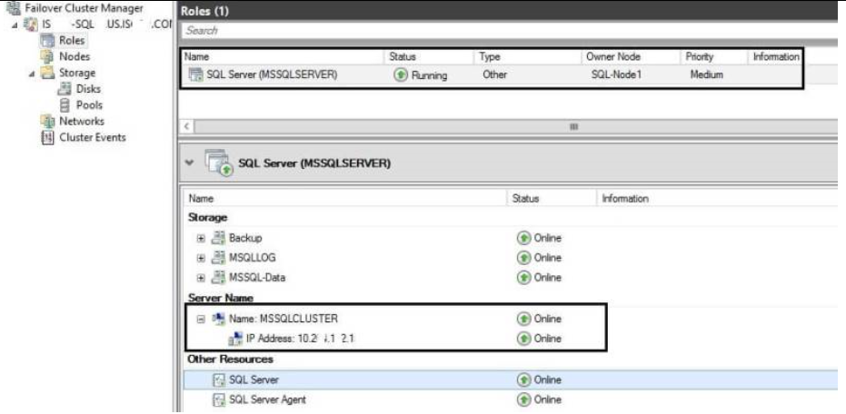

The SQL Server instance (MSSQLSERVER) will under the failover over cluster as a “Roles”, and it contains “Server Name”, “Storage”, and “Other Resources” within the roles.

The SQL Server instances dependancy as below:

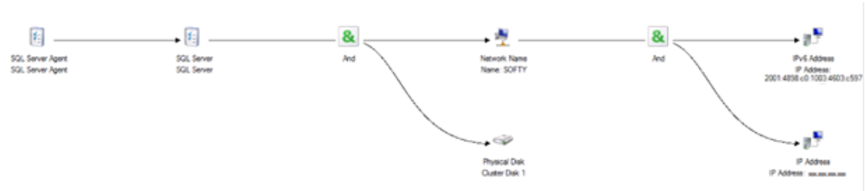

The applications we used under Failover Cluster is SQL 2016 AlwaysOn Failover Cluster Instance, the cluster configuration will be handled by the applications during SQL 2016 High Availability setup.

* 1. Hardware Infrastructure Components Configuration Details

**Web Servers (Host 1 and Host 2 – HPE ProLiant DL360) Hardware Configuration**

|  |  |  |  |  |
| --- | --- | --- | --- | --- |
| ***Category*** | ***Model/Value/Setting*** | ***Model/Value/Setting*** | ***Model/Value/Setting*** | ***Model/Value/Setting*** |
| ***System Information*** |  | | | |
| Server Name | STOCBDSWS01 (Host 1) | STOCBDSWS02 (Host 2) | HVOCBDSWS01 (Host 1) | HVOCBDSWS02 (Host 2) |
| Machine | HP DL360 G9 E5-2620v4 1P Svr | HP DL360 G9 E5-2620v4 1P Svr | HP DL360 G9 E5-2620v4 1P Svr | HP DL360 G9 E5-2620v4 1P Svr |
| Serial No. | SGH745S8WV | SGH745S8WS | SGH838XCYM | SGH838XCYT |
| Processor – Model | 1 x Xeon E5-2620V4 8 Cores with 20MB cache 2.10GHz CPU | 1 x Xeon E5-2620V4 8 Cores with 20MB cache 2.10GHz CPU | 1 x Xeon E5-2620V4 8 Cores with 20MB cache 2.10GHz CPU | 1 x Xeon E5-2620V4 8 Cores with 20MB cache 2.10GHz CPU |
| Memory | 64 GB | 64 GB | 64 GB | 64 GB |
| Hard Disks | 300 GB x 2 (RAID 1) | 300 GB x 2 (RAID 1) | 300 GB x 2 (RAID 1) | 300 GB x 2 (RAID 1) |
| Power Supply | HPE 500W FS Plat Ht Plg Pwr Supply Kit x 2 | HPE 500W FS Plat Ht Plg Pwr Supply Kit x 2 | HPE 500W FS Plat Ht Plg Pwr Supply Kit x 2 | HPE 500W FS Plat Ht Plg Pwr Supply Kit x 2 |
| Network Interface Card | HPE Ethernet 1Gb 4P 331FLR Adptr | HPE Ethernet 1Gb 4P 331FLR Adptr | HPE Ethernet 1Gb 4P 331FLR Adptr | HPE Ethernet 1Gb 4P 331FLR Adptr |
| C: | 180GB | 180GB | 180GB | 180GB |
| D: | 100GB | 100GB | 300GB | 300GB |

**Application Servers (Host 3 and Host 4 – HPE ProLiant DL360) Hardware Configuration**

|  |  |  |  |  |
| --- | --- | --- | --- | --- |
| ***Category*** | ***Model/Value/Setting*** | ***Model/Value/Setting*** | ***Model/Value/Setting*** | ***Model/Value/Setting*** |
| ***System Information*** |  | | | |
| Server Name | STOCBDSAS01 (Host 3) | STOCBDSAS02 (Host 4) | HVOCBDSAS01 (Host 3) | HVOCBDSAS02 (Host 4) |
| Machine | HP DL360 G9 E5-2620v4 1P Svr | HP DL360 G9 E5-2620v4 1P Svr | HP DL360 G9 E5-2620v4 1P Svr | HP DL360 G9 E5-2620v4 1P Svr |
| Serial No. | SGH745S8WT | SGH745S8WR | SGH838XCYJ | SGH838XCYR |
| Processor – Model | 1 x Xeon E5-2620V4 8 Cores with 20MB cache 2.10GHz CPU | 1 x Xeon E5-2620V4 8 Cores with 20MB cache 2.10GHz CPU | 1 x Xeon E5-2620V4 8 Cores with 20MB cache 2.10GHz CPU | 1 x Xeon E5-2620V4 8 Cores with 20MB cache 2.10GHz CPU |
| Memory | 64 GB | 64 GB | 64 GB | 64 GB |
| Hard Disks | 300 GB x 2 (RAID 1) | 300 GB x 2 (RAID 1) | 300 GB x 2 (RAID 1) | 300 GB x 2 (RAID 1) |
| Power Supply | HPE 500W FS Plat Ht Plg Pwr Supply Kit x 2 | HPE 500W FS Plat Ht Plg Pwr Supply Kit x 2 | HPE 500W FS Plat Ht Plg Pwr Supply Kit x 2 | HPE 500W FS Plat Ht Plg Pwr Supply Kit x 2 |
| Network Interface Card | HPE Ethernet 1Gb 4P 331FLR Adptr | HPE Ethernet 1Gb 4P 331FLR Adptr | HPE Ethernet 1Gb 4P 331FLR Adptr | HPE Ethernet 1Gb 4P 331FLR Adptr |
| C: | 180GB | 180GB | 180GB | 180GB |
| D: | 100GB | 100GB | 300GB | 300GB |

**Database Servers (DB Server 1 and DB Server 2 – HPE ProLiant DL360) Hardware Configuration**

|  |  |  |  |  |
| --- | --- | --- | --- | --- |
| ***Category*** | ***Model/Value/Setting*** | ***Model/Value/Setting*** | ***Model/Value/Setting*** | ***Model/Value/Setting*** |
| ***System Information*** |  | | | |
| Server Name | STOCBDSDB001 | STOCBDSDB002 | HVOCBDSDB001 | HVOCBDSDB002 |
| Machine | HP DL360 G9 E5-2620v4 1P Svr | HP DL360 G9 E5-2620v4 1P Svr | HP DL360 G9 E5-2620v4 1P Svr | HP DL360 G9 E5-2620v4 1P Svr |
| Serial No. | SGH905YYPQ | SGH905YYPM | SGH838XCYN | SGH905YYPK |
| Processor – Model | 1 x Xeon E5-2620V4 8 Cores with 20MB cache 2.10GHz CPU | 1 x Xeon E5-2620V4 8 Cores with 20MB cache 2.10GHz CPU | 1 x Xeon E5-2620V4 8 Cores with 20MB cache 2.10GHz CPU | 1 x Xeon E5-2620V4 8 Cores with 20MB cache 2.10GHz CPU |
| Memory | 64 GB | 64 GB | 64 GB | 64 GB |
| Hard Disks | 300 GB x 2 (RAID 1) | 300 GB x 2 (RAID 1) | 300 GB x 2 (RAID 1) | 300 GB x 2 (RAID 1) |
| Power Supply | HPE 500W FS Plat Ht Plg Pwr Supply Kit x 2 | HPE 500W FS Plat Ht Plg Pwr Supply Kit x 2 | HPE 500W FS Plat Ht Plg Pwr Supply Kit x 2 | HPE 500W FS Plat Ht Plg Pwr Supply Kit x 2 |
| Network Interface Card | HPE Ethernet 1Gb 4P 331FLR Adptr | HPE Ethernet 1Gb 4P 331FLR Adptr | HPE Ethernet 1Gb 4P 331FLR Adptr | HPE Ethernet 1Gb 4P 331FLR Adptr |
| Fibre Channel | EMULEX 16GBPS SINGLE PORT | EMULEX 16GBPS SINGLE PORT | EMULEX 16GBPS SINGLE PORT | EMULEX 16GBPS SINGLE PORT |
| C: | 200GB | 200GB | 200GB | 200GB |
| D: | 3000GB | 3000GB | 300GB | 300GB |
| LUN – M: MSDTC | 1GB | | 1GB | |
| LUN – F: SystemDB | 10GB | | 10GB | |
| LUN – T: TempDB | 10GB | | 10GB | |
| LUN – S: User1 DB Backup Dump | 250GB | | 250GB | |
| LUN –L:User1 DB Log | 60GB | | 60GB | |
| LUN – J: User1 DB | 20GB | | 20GB | |

**Monitoring Servers (HPE ProLiant DL360) Hardware Configuration**

|  |  |  |  |  |
| --- | --- | --- | --- | --- |
| ***Category*** | ***Model/Value/Setting*** | ***Model/Value/Setting*** | ***Model/Value/Setting*** | ***Model/Value/Setting*** |
| ***System Information*** |  | |  | |
| Server Name | STOCBDSMON001 | STOCBDSMON002 | HVOCBDSMON001 | HVOCBDSMON002 |
| Machine | HP DL360 G9 E5-2620v4 1P Svr | HP DL360 G9 E5-2620v4 1P Svr | HP DL360 G9 E5-2620v4 1P Svr | HP DL360 G9 E5-2620v4 1P Svr |
| Serial No. | SGH905YYPN | SGH905YYPP | SGH905YYPL | SGH83XCYQ |
| Processor – Model | 1 x Xeon E5-2620V4 8 Cores with 20MB cache 2.10GHz CPU | 1 x Xeon E5-2620V4 8 Cores with 20MB cache 2.10GHz CPU | 1 x Xeon E5-2620V4 8 Cores with 20MB cache 2.10GHz CPU | 1 x Xeon E5-2620V4 8 Cores with 20MB cache 2.10GHz CPU |
| Memory | 64 GB | 64 GB | 64 GB | 64 GB |
| Hard Disks | 300 GB x 2 (RAID 1) | 300 GB x 2 (RAID 1) | 300 GB x 2 (RAID 1) | 300 GB x 2 (RAID 1) |
| Power Supply | HPE 500W FS Plat Ht Plg Pwr Supply Kit x 2 | HPE 500W FS Plat Ht Plg Pwr Supply Kit x 2 | HPE 500W FS Plat Ht Plg Pwr Supply Kit x 2 | HPE 500W FS Plat Ht Plg Pwr Supply Kit x 2 |
| Network Interface Card | HPE Ethernet 1Gb 4P 331FLR Adptr | HPE Ethernet 1Gb 4P 331FLR Adptr | HPE Ethernet 1Gb 4P 331FLR Adptr | HPE Ethernet 1Gb 4P 331FLR Adptr |
| Fibre Channel | EMULEX 16GBPS SINGLE PORT | EMULEX 16GBPS SINGLE PORT | EMULEX 16GBPS SINGLE PORT | EMULEX 16GBPS SINGLE PORT |
| C: | 200GB | 200GB | 200GB | 200GB |
| D: | 300GB | 300GB | 300GB | 300GB |
| LUN – K: SysInfo | 300GB | | 300GB | |
| LUN L: Monitoring Log | 10GB | | 10GB | |
|  |  | |  | |

**Data Centre Core Switches Hardware Configuration**

|  |  |
| --- | --- |
| **Model** | Cisco WS-C3850-24T-E |
| **Total 10/100/1000 Ports** | 24 |
| **Power Supply** | PWR-C1-350WAC x 2 |
| **StackWise-480** | Yes |
| **Switching capacity** | 92 Gbps |
| **Stacking bandwidth** | 480 Gbps |
| **Total number of MAC addresses** | 32,000 |
| **Total number of IPv4 routes (ARP plus learned routes)** | 24,000 |
| **DRAM** | 4 GB |
| **Flash** | 2 GB |
| **VLAN IDs** | 4,000 |
| **Total routed ports per 3850 stack** | 208 |
| **Forwarding Rate** | 68.4 Mpps |
| **Mean Time Between Failure** | 303,230 |

**Core Routers (ASR-1001X-5G-K9) Hardware Configuration**

|  |  |
| --- | --- |
| **Model** | Cisco ASR 1001-X |
| **Built-in Gigabit Ethernet ports** | 6 |
| **Built-in 10 Gigabit Ethernet ports** | 2 x 10Gb (SFP+) ports |
| **Power Supply** | Dual power supply |
| **ESP bandwidth** | 10 Gbps |
| **Cisco IOS XE Software**  **release** | Cisco IOS XE Software Release 3.1 2.0 |
| **Default Memory** | 8 GB DRAM, shared cross route processor, ESP, and SIP |
| **External USB flash memory** | 1 GB USB Flash Memory support |
| **VLAN IDs** | 4,000 |
| **Total routed ports per 3850 stack** | 208 |
| **Forwarding Rate** | 68.4 Mpps |
| **WS-C3850-24T** | 303,230 |

**Firewall (To be provided by the Club)**

**Video Encoders Hardware Configuration**

|  |  |
| --- | --- |
| **Model** | Elemental encoder L025AE |
| **Input** | |
| **Number/signal type** | 1 HDMI digital video (HDCP compliant)  1 HD-SDI |
| **Resolution Range** | 720p, 1080i, 1080p, 4K, 4096X2160p, NTSC, and PAL |
| **Video Processing** | |
| **Compression** | H.264/AVC (ITU H.264, ISO/IEC 14496-10)  Encoding profiles: High;  Encoding levels: 4.0  GOP Size: 1sec |
| **Bit rate** | 5Mbps |
| **Latency** | 300 msec (encode) |
| **Video Output** | |
| **Scaled resolution** | 720p |
| **Frame rate** | 50fps |
| **Streaming Protocol** | RTP |
| **Audio Input** | |
| **Digital**  **Number/signal type** | 16 audio channel, digital de-embedded from HDMI,SDI |
| **Audio Processing** | |
| **Compression** | AAC-LC MPEG-4 (ISO/IEC 14496-3:2005) |
| **Bit rate** | 128 kbps |
| **Coding mode** | Dual Mono |
| **Audio remix** | Audio channel 1 and 3 remix to video stream.  Audio channel 2 and 4 remix to audio stream. |
| **Communication** | |
| **Ethernet control** | 2 x RJ45, 10/100/1000Base-T, half/full duplex with autodetect |
| **Storage** | |
| **Harddisk** | 1TB HDD |

**OCB Switches Hardware Configuration**

|  |  |
| --- | --- |
| **Model** | Cisco WS-C3650-24TS-S |
| **Total 10/100/1000 Ports** | 24 |
| **Power Supply** | PWR-C2-250WAC x 2 |
| **StackWise-480** | Yes |
| **Switching capacity** | 88 Gbps |
| **Stacking bandwidth** | 160 Gbps |
| **Total number of MAC addresses** | 32,000 |
| **Total number of IPv4 routes (ARP plus learned routes)** | 24,000 |
| **DRAM** | 4 GB |
| **Flash** | 2 GB |
| **VLAN IDs** | 4,094 |
| **Total routed ports per 3650 stack** | 208 |
| **Forwarding Rate** | 41.66 Mpps |
| **Mean Time Between Failure** | 661,800 hrs |

**OCB Server**

|  |  |
| --- | --- |
| ***Category*** | ***Model/Value/Setting*** |
| Machine | HP DL20 G9 E3-1270v6 1P Svr |
| Serial No. | - |
| Processor – Model | 1 x Xeon E3-1270V6 4 Cores with 8MB cache 3.8GHz CPU |
| Memory | 8 GB |
| Hard Disks | 1TB x 2 (RAID 1) |
| Power Supply | HPE 900W AC 240VDC Pwr Input Mdl FIO Kit x 2 |
| Network Interface Card | HPE embedded 1Gb 2-port 332i network Adapter |
| C: | 100GB |
| D: | 900GB |

**Signage player (2 x HDMI output)**

|  |  |
| --- | --- |
| ***Category*** | ***Model/Value/Setting*** |
| Machine | iBase SI-102N |
| Processor – Model | AMD G-Series; Quad Core GX-424CC @ 2.4GHz |
| Memory | 8 GB |
| Hard Disks | 64GB SSD |
| Network Interface Card | 1 x GbE (Realtek RTL 8111DP) |
| Video Output | 2 x HDMI 1.4a |
| Audio Output | 2 x Microphone audio connector for line-in / line-out |
| Operating System | Windows® 10 IoT Enterprise 2016 LTSB |

**Signage player (3 x HDMI output)**

|  |  |
| --- | --- |
| ***Category*** | ***Model/Value/Setting*** |
| Machine | iBase SI-613 |
| Processor – Model | Intel® Skylake-S DT Processor |
| Memory | 64 GB |
| Hard Disks | 64GB SSD |
| Network Interface Card | 1 x Gigabit LAN |
| Video Output | 3 x HDMI 2.0 |
| Audio Output | 2 x Microphone audio connector for line-in / line-out |
| Operating System | Windows® 10 IoT Enterprise 2016 LTSB |

**Signage player (2 x DP output)**

|  |  |
| --- | --- |
| ***Category*** | ***Model/Value/Setting*** |
| Machine | iBase SI-614 |
| Processor – Model | 7th Generation Intel® Desktop Processor |
| Memory | 16 GB |
| Hard Disks | 128GB SSD |
| Network Interface Card | 1 x Gigabit LAN |
| Video Output | 4 x DP 1.4 compatible |
| Audio Output | 1 x Microphone audio connector for line-out |
| Operating System | Windows® 10 64-bit Enterprise |

**Media Gateway (2 x RF input)**

|  |  |
| --- | --- |
| ***Category*** | ***Model/Value/Setting*** |
| Machine | WellAV CMP201 |
| Processor – Model | Embedded |
| Memory | Embedded |
| Hard Disks | Embedded |
| Network Interface Card | 1 x Gigabit LAN with 8 ports |
| Video Output | 8 modulated frequency outputs |
| Audio Output | N/A |
| Operating System | Windows® 10 64-bit Enterprise |

* 1. System Management Infrastructure Components Configuration Details

Integration with EMS

At the mass rollout stage, the software will be installed and distributed through the remote agent. It is noted that EMS is under migration by end of year 2017. TVDMS will follow the Club’s standard and deploy the new EMS agent (IBM Big Fix) to headend and local OCB servers at initial stage prior to OCBDS pilot site installation and mass roll out so that the OCBDS can be ready for the Club’s EMS once EMS migration is commenced.

Players’ software update will be handled by the Content Manager of Eyecon R2.

Audit Trail

{Specify the audit trail on application, security and system levels.}

Audit Trial on application level

OCBDS Administrator will be allowed to review a list of previously recorded alerts and events relative to each Player under OCBDS.

* support detailed actions and activities logging for all user login accounts
* Property
* User name
* Record date time
* Audit trail level
* Grey – Information
* Yellow – Warning
* Red – Alert

Audit log in WSS?

* 1. Security Infrastructure Components Configuration Details

User Account

LDAP Window user login

EYECON HQ will be performing user authentication by Lightweight Directory Access Protocol(LDAP). It will connect with Club’s Active Directory tenant. Based on the Window user authentication behavior, user can access EYECON Content Manager by using their Club’s user account. Single Authentication will be avoided and user logged in to the corporate domain will be required to log in again to the OCBDS.

Anti-virus Software

### TrendMicro OfficeScan

TrendMicro OfficeScan will be provided by the Club and it will be installed in headend servers and local OCB servers for virus protection. There will be no full scanning nor scheduled, scanning on servers, any detected virus from user input through admin console will be deleted directly without notification. Virus definition will be automatically carried out under the Club’s schedule and no additional agent or subscription to the Club’s corporate domain is required. TVDMS will carry out performance verification on the effect of installation of OfficeScan on OCBDS servers, if there is any adverse effect on the performance, an exclusion list on particular network path, shared storage shall be provided by TVDMS.

WSS Admin Login? Also, HKJC’s client need to install WSS cert and register their external IP in WSS in order to use it.

* 1. Video Encoder Configuration

|  |  |  |  |  |
| --- | --- | --- | --- | --- |
|  | Duty Video Encoder | Standby Video Encoder | DR Duty Video Encoder | DR Standby Video Encoder |
| ip | 10.160.6.1 | 10.160.6.3 | 10.160.22.1 | 10.160.22.3 |
| login ID | dmn | dmn | dmn | dmn |
| pwd | dmn888ipTV | dmn888ipTV | dmn888ipTV | dmn888ipTV |
| Resolution | 1280x720 | 1280x720 | 1280x720 | 1280x720 |
| Frame | 50 fps | 50 fps | 50 fps | 50 fps |
| Latency | 300ms | 300ms | 300ms | 300ms |
| GOP | 1s | 1s | 1s | 1s |
| Video Bitrate | 5000kbps | 5000kbps | 5000kbps | 5000kbps |
| Audio Bitrate | 128kbps | 128kbps | 128kbps | 128kbps |
| Rate Control | CBR | CBR | CBR | CBR |
| H.264 Profile | High | High | High | High |
| Profile Level | 4.0 | 4.0 | 4.0 | 4.0 |
| Streaming Method | Push | Push | Push | Push |
|  | Multicast | Multicast | Multicast | Multicast |
| Destination | rtp://239.194.14.1/2 | rtp://239.194.14.1/2 | rtp://239.194.14.33/34 | rtp://239.194.14.33/34 |
| Port Range | 12340 | 12340 | 12340 | 12340 |
| MTU | 1500 | 1500 | 1500 | 1500 |
| TTL | 10 | 10 | 10 | 10 |
| DiffServ QoS Level | High (CS4) | High (CS4) | High (CS4) | High (CS4) |

# Appendix A: Development Test Configuration at Top Vista (Vendor)

# 

# Appendix B: UAT/SAT Test Configuration

1. **SAT-1 Testbed Network Diagram**

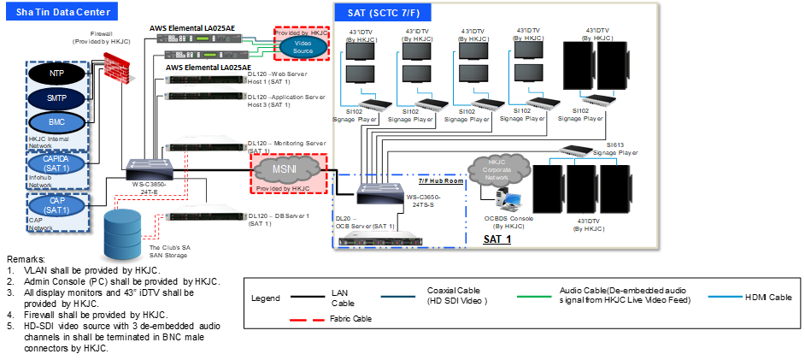

1. **SAT-1 Testbed Network Diagram**

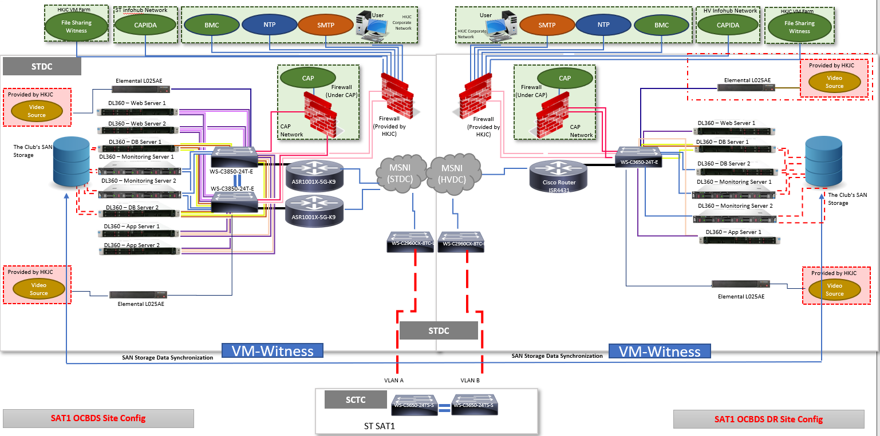

1. **SAT-2 Testbed Network Diagram**

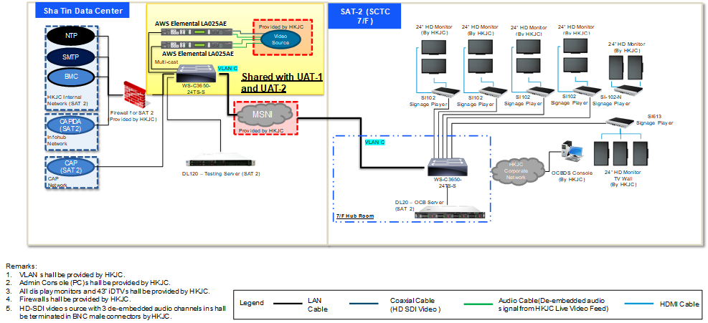

1. **UAT-1 Testbed Network Diagram**

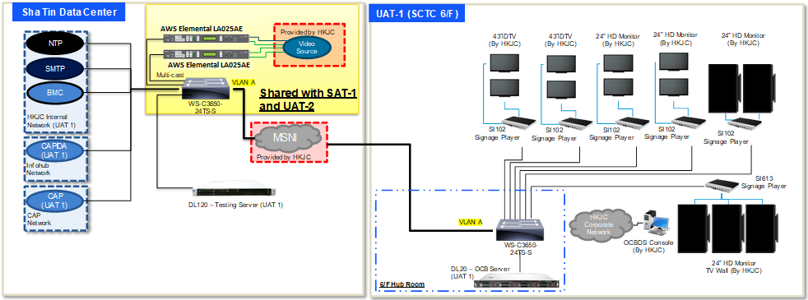

1. **UAT-2 Testbed Network Diagram**

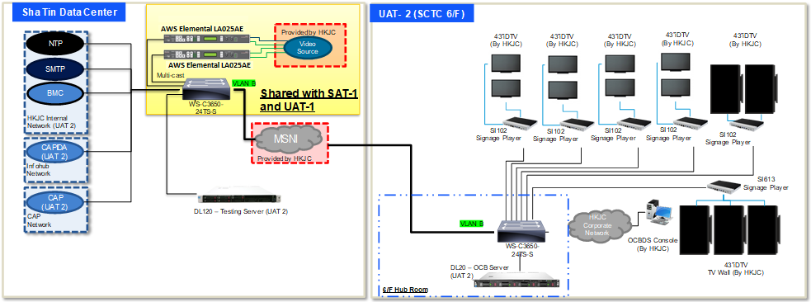

1. **Production Server Racks**

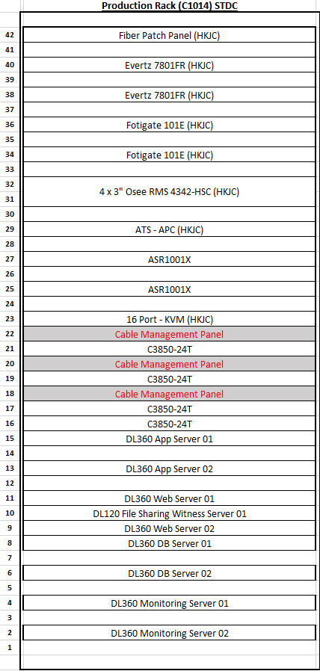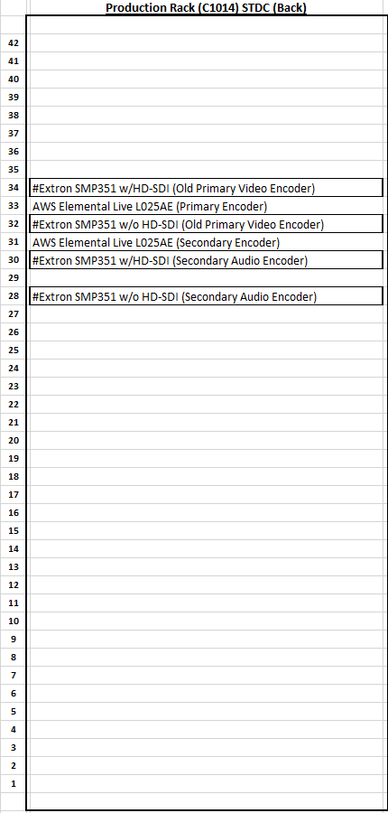 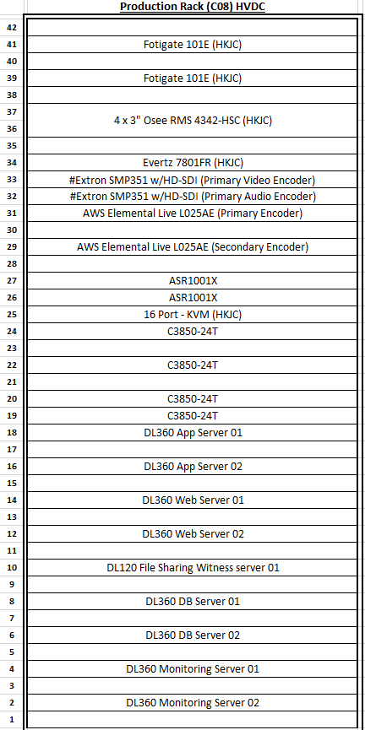

1. **Testbed Server Racks**

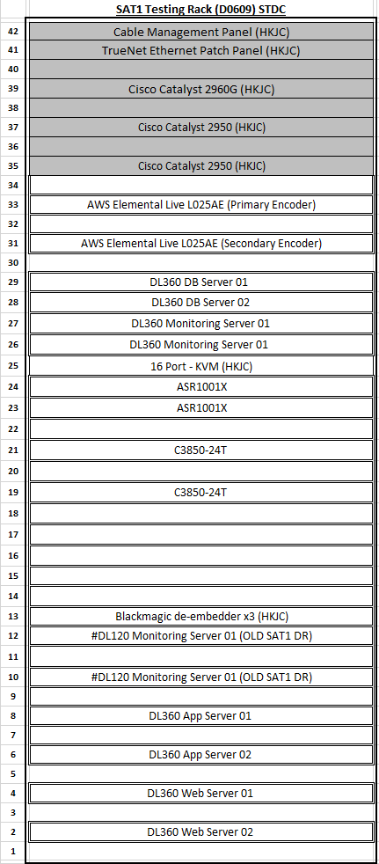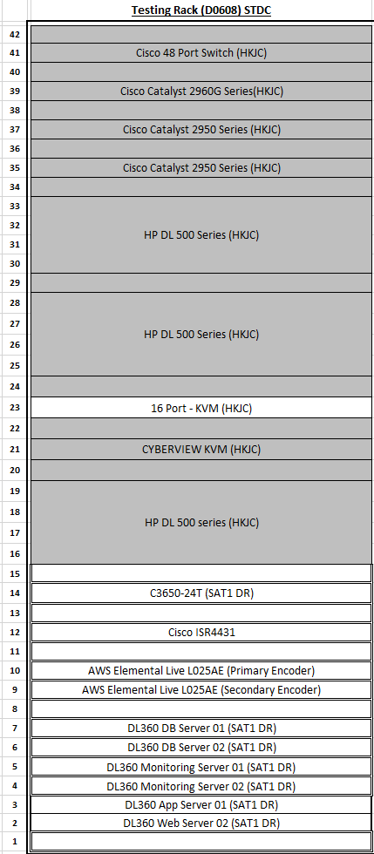 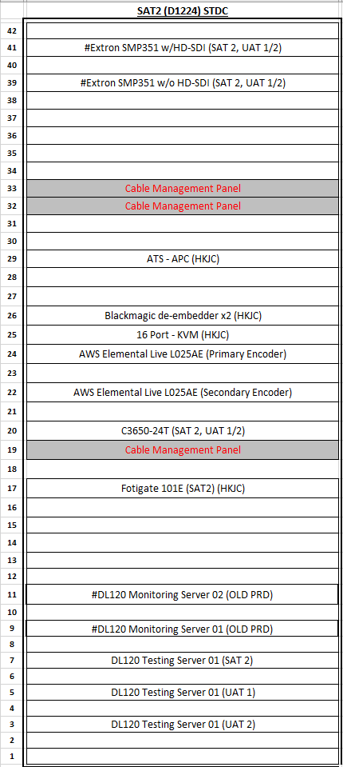

# Appendix C: CR006 - DR Site Setup

1. **DR Site System Configuration**

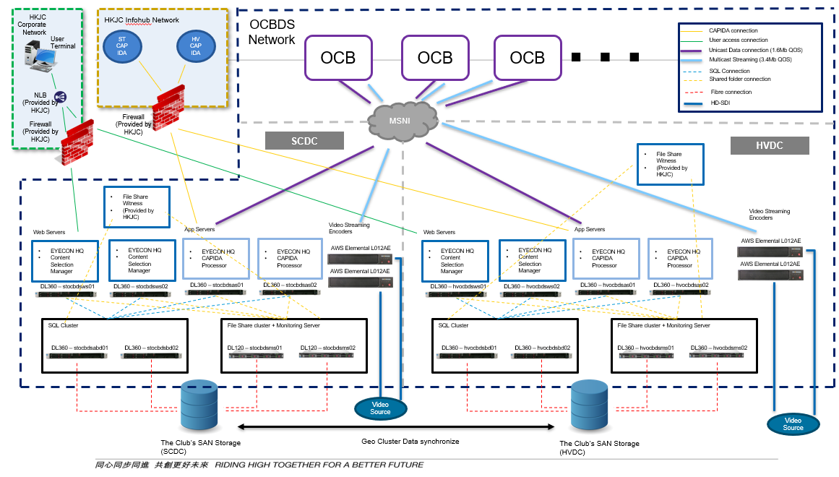

1. **Failover – 3 levels**
2. CAPIDA processor failover
   1. Situation:
      1. STDC CAPIDA source connection lose
   2. Procedures:
      1. Keep using STDC Site’s CAPIDA processor, change the CAPIDA connection from STDC to HVDC
3. Video encoder failover
   1. Situation:
      1. STDC Video source signal lose
   2. Procedures:
      1. Stop encoders on STDC
      2. Enable encoders on HVDC
4. Full Site failover
   1. Situation:
      1. Any situation not include in the above cases
   2. Procedure:
      1. Perform Video Encoder Failover
      2. Stop CAPIDA processor on STDC Application Server
      3. Stop IIS on STDC Web Server
      4. Stop BMC Monitoring Service on STDC Monitoring Server
      5. Switch SQL cluster node from STDC to HVDC
      6. Switch file sharing cluster node form STDC to HVDC
      7. Enable IIS on HVDC Web server
      8. Enable CAPIDA processor on HVDC App server
      9. Start BMC Monitoring Service on HVDC Monitoring server
5. **Failover Arrangement**
6. Failover execute manually
7. Club’s GTM transfer Club’s user terminal connection from STDC to HVDC
8. OCB Gateway server auto connect to HVDC once STDC connection lose over 1 mins
9. Failover task pre-define PowerShell script
10. Those PowerShell script will host in OCBDS servers

# Appendix D: CR008/CR013 – Video Quality Enhancement

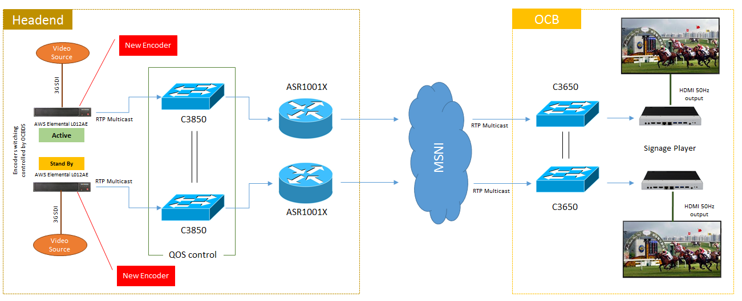

Video encoder (TBC)

Video encoder (TBC)

# Appendix E: Display External Webpage

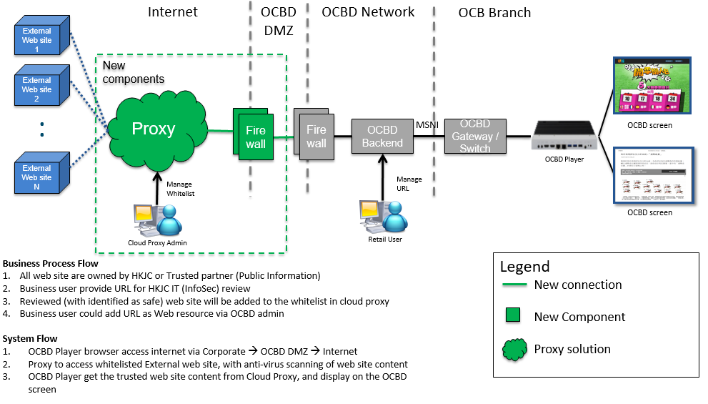

# Appendix F: TV Wall

